- Patron ID = Barcode:
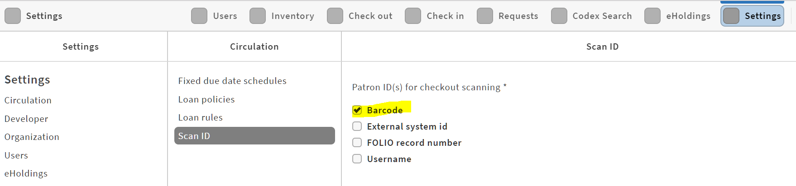
Checkout screen is fine:
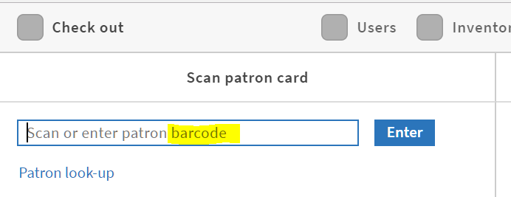

- Patron ID = External System ID
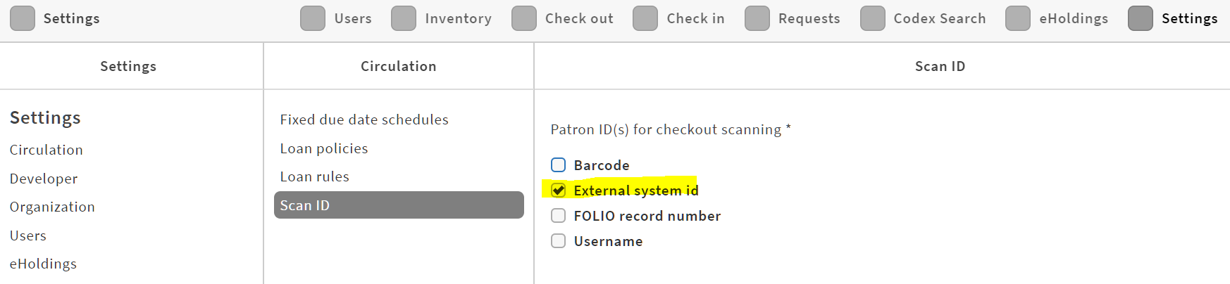
Checkout screen is odd: maybe should be external system ID instead?
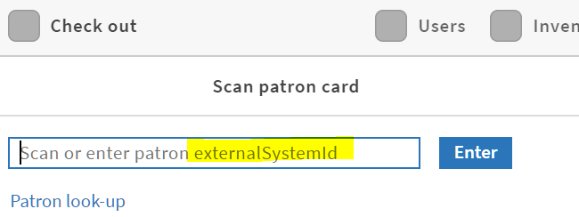

- Patron ID = FOLIO Record Number
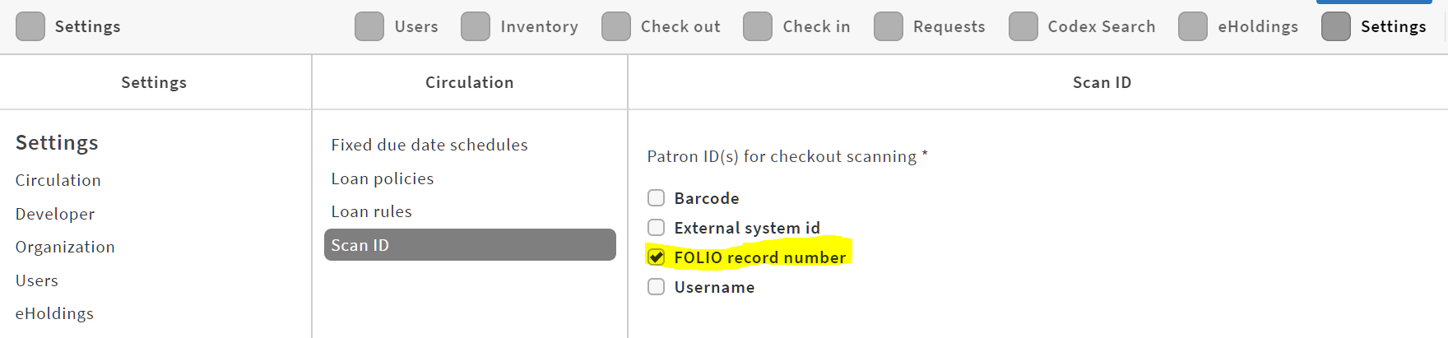
Checkout screen: should it say FOLIO record number instead?
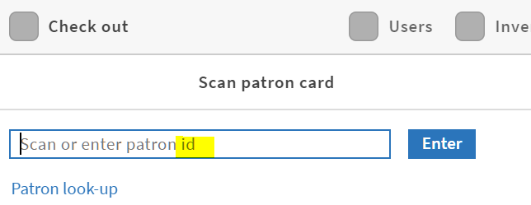

- Patron ID = Username
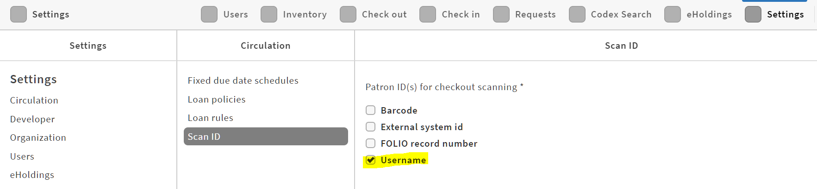
Checkout screen is fine.
