Step to reproduce in https://folio-snapshot.dev.folio.org/:
- Add to SP Circ Desk 1 an exceptional closed period (from the first to the 6th of September) and save it
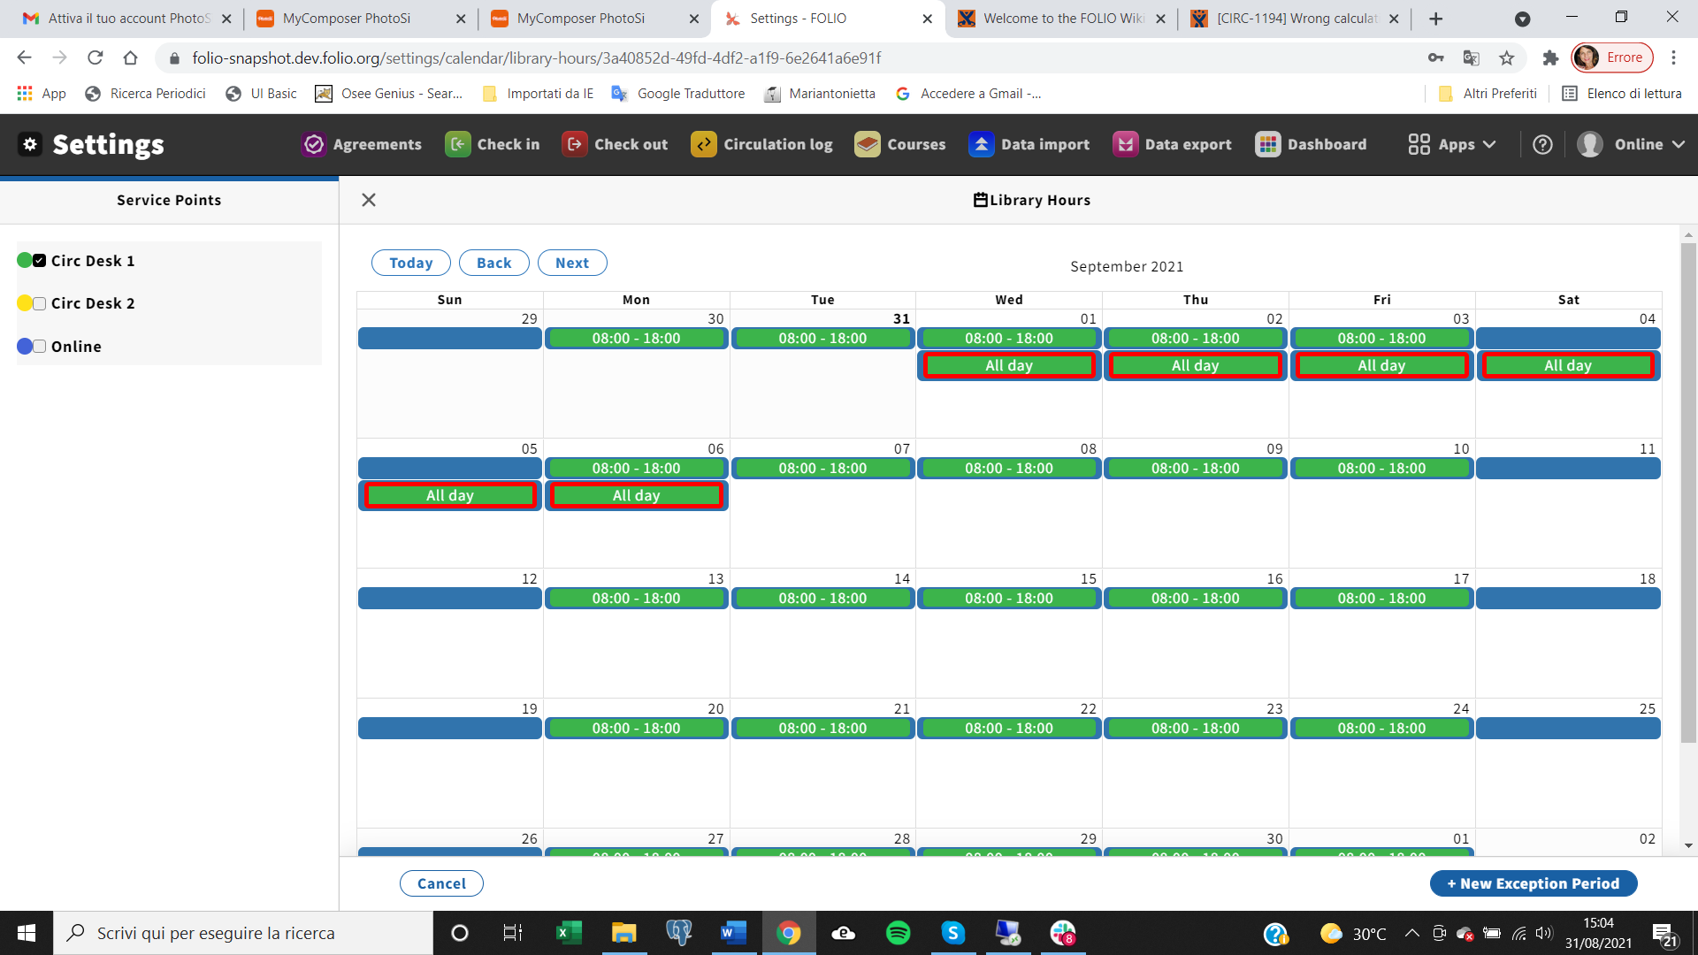

- In the loan policies settings for loan “one-week”, set the “Closed library due date management=
Move to the end of the next open day”
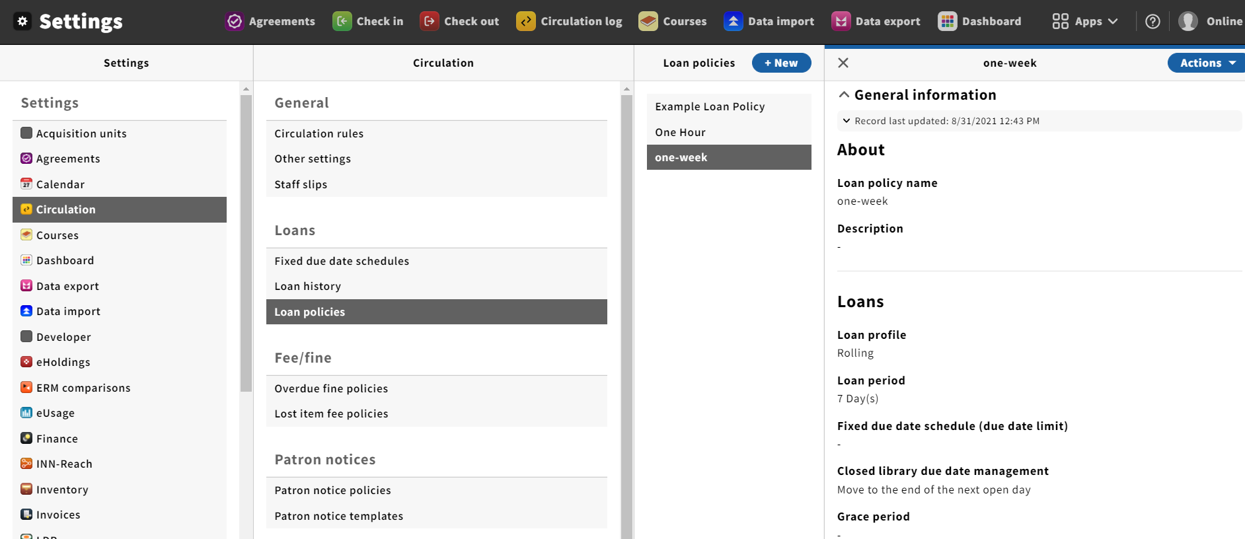
- Loan the item with barcode 645398607547 to user 11111 (Barannyk, Roman )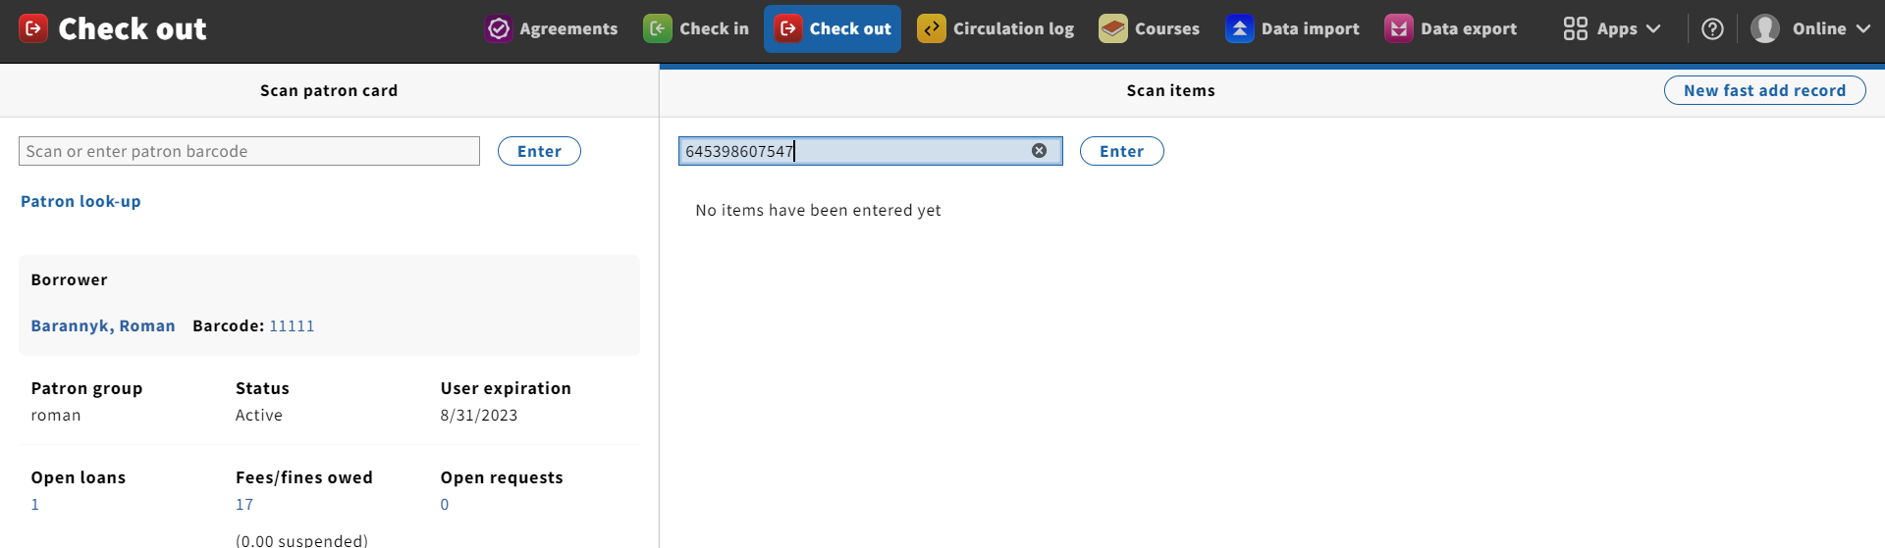
- The system will return this message “Calendar timetable is absent for requested date”:
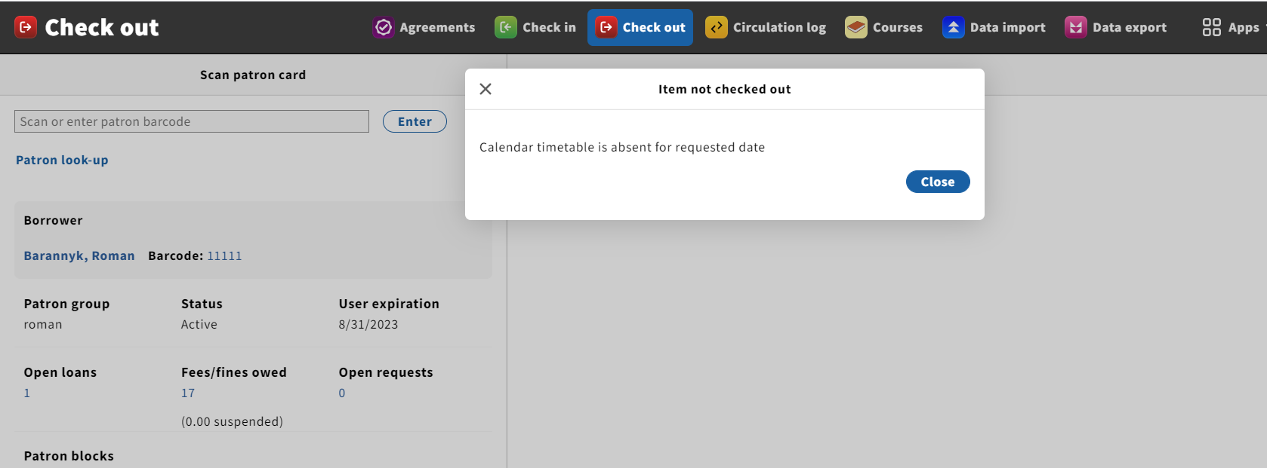
What does it means?
If the the closed days are not excluded from the calculation except the case when the due date falls on a closed day, the due date should be moved according to "Move to the end of the next open day", isn’t it?
What am’I doing wrong?

