Evidence-CIRC-1174

- Fee/fine open: “Charge amount for item 50.00 and Lost item processing fee 25.00”
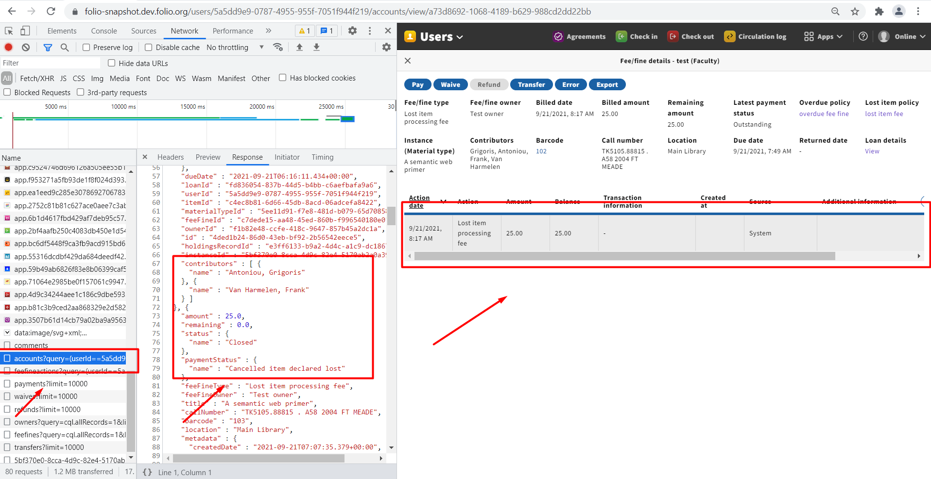

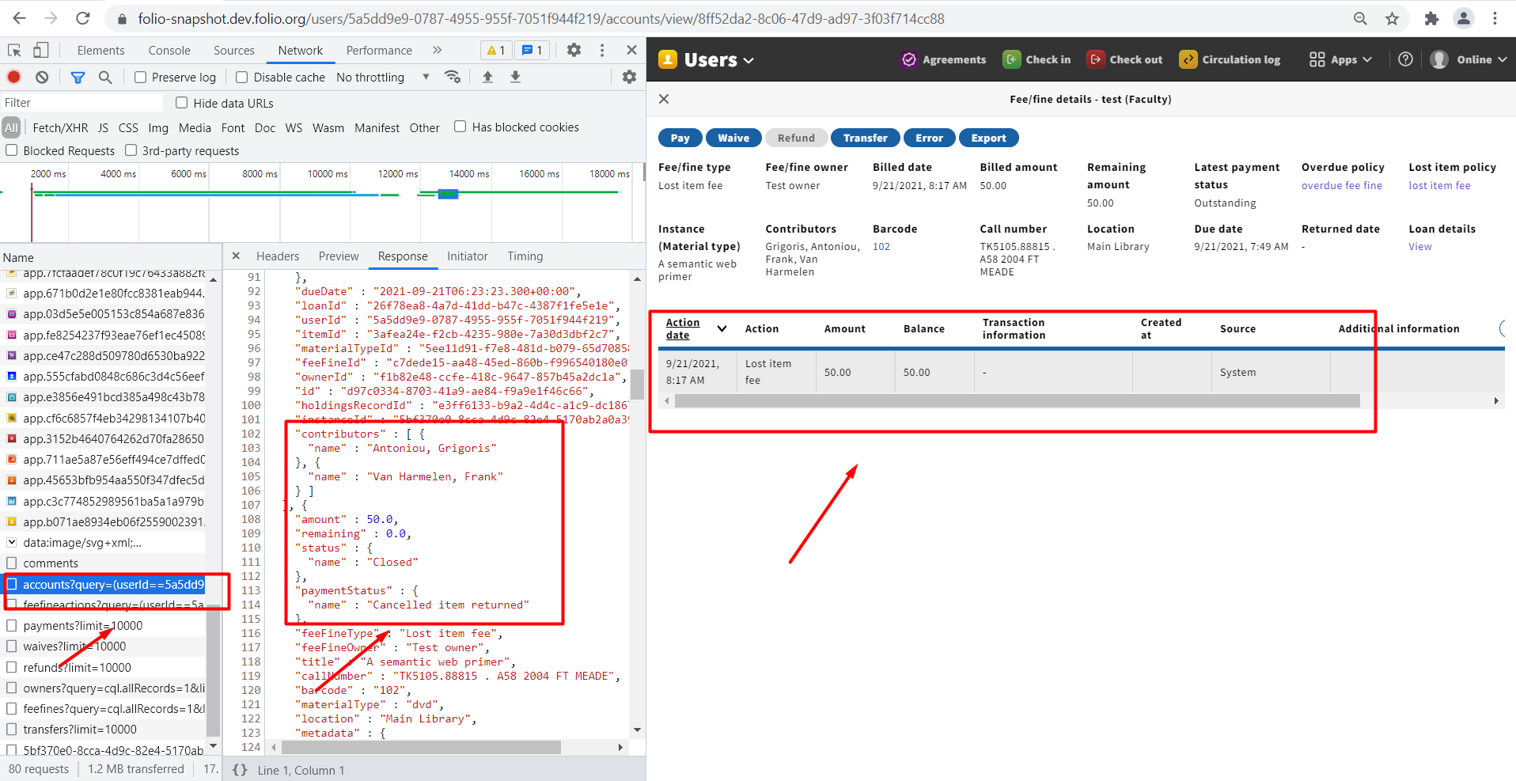

2.Contributors “Maximum overdue fine 10.00”
