Pressure Test of Checkin
According to Martin Tran, Checkin has memory leak problem, and we have a relevant test. The main modules tested are as follows:
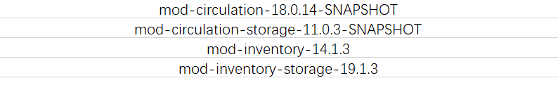

The main features of the database are as follows:
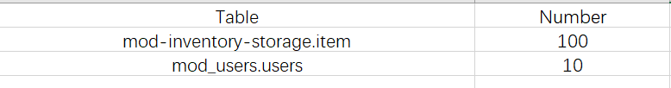

The JMeter test script is provided by Martin Tran, and the test information is as follows:
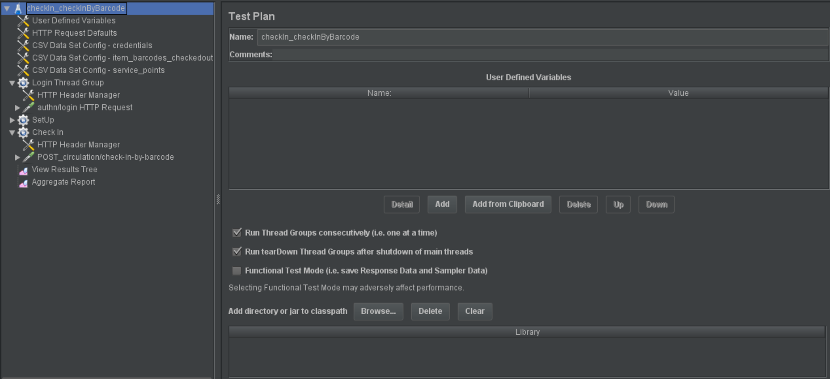
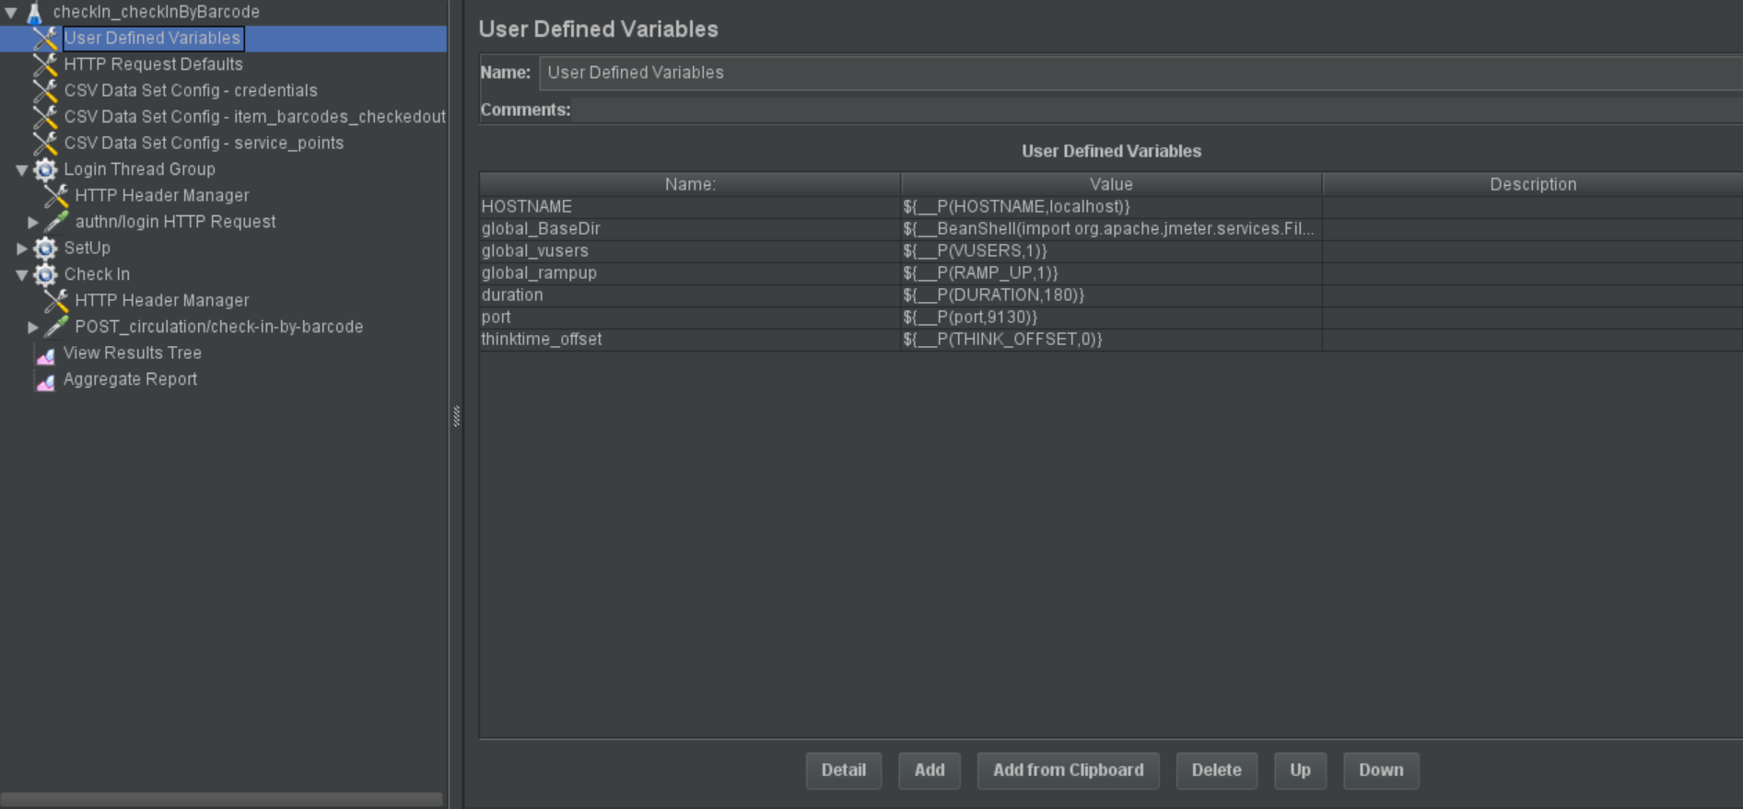
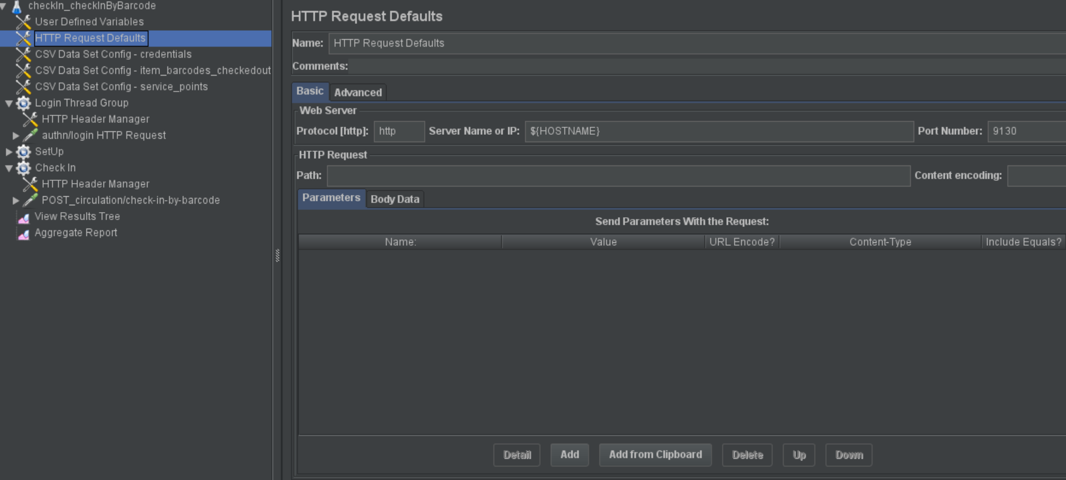
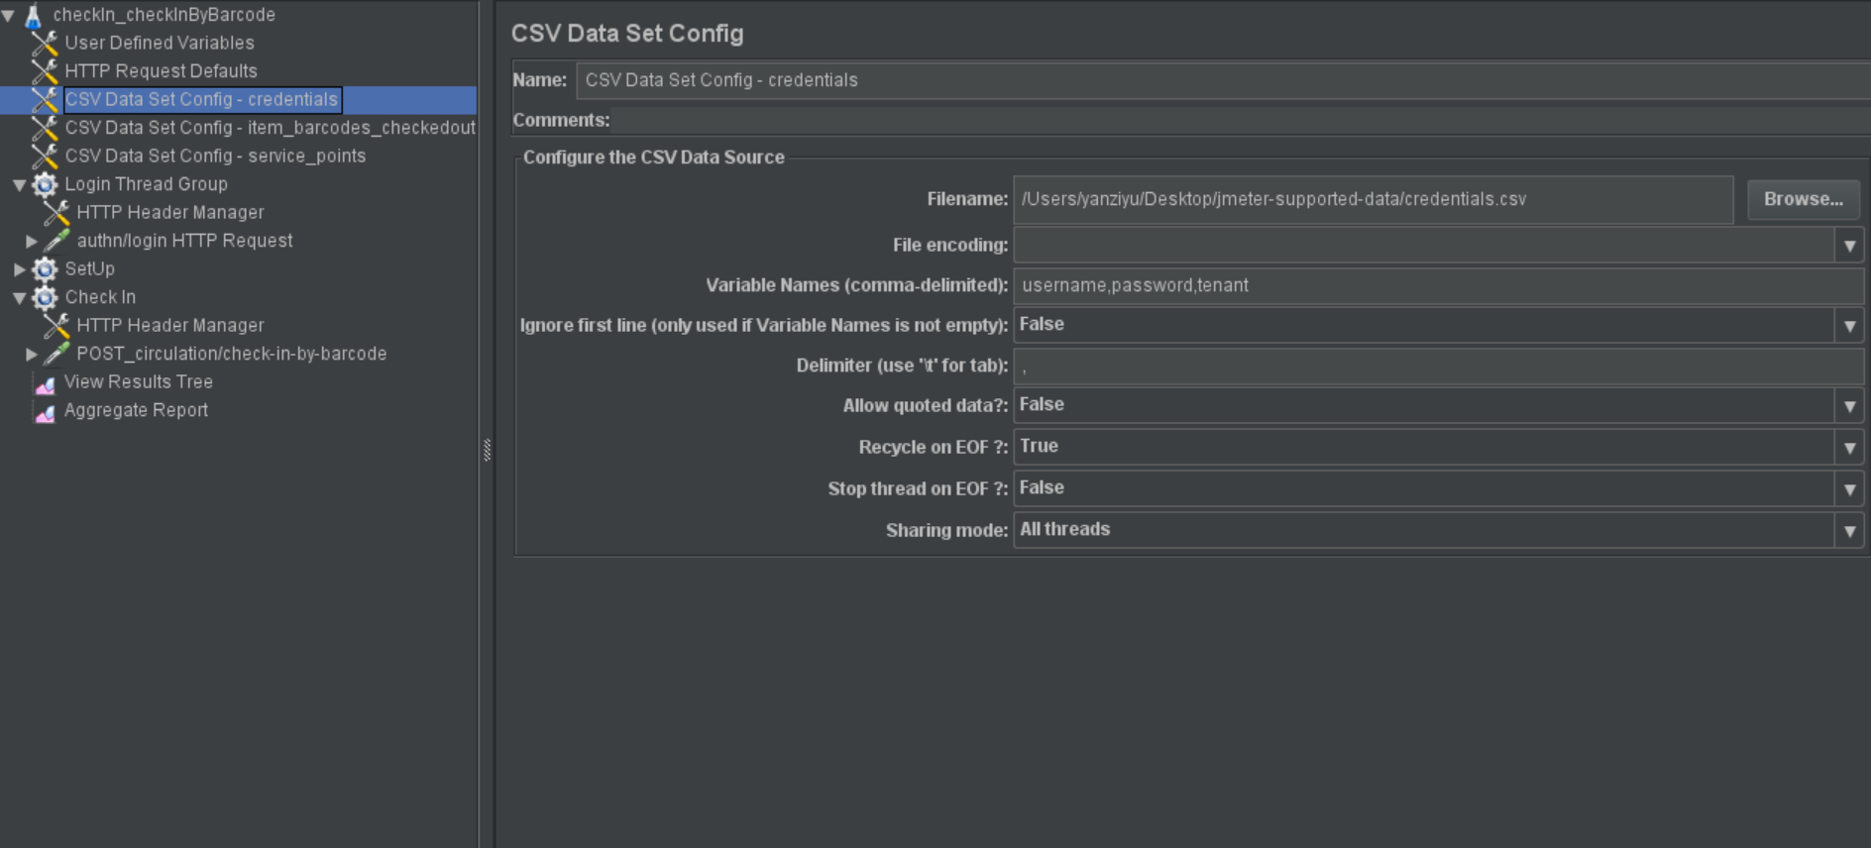
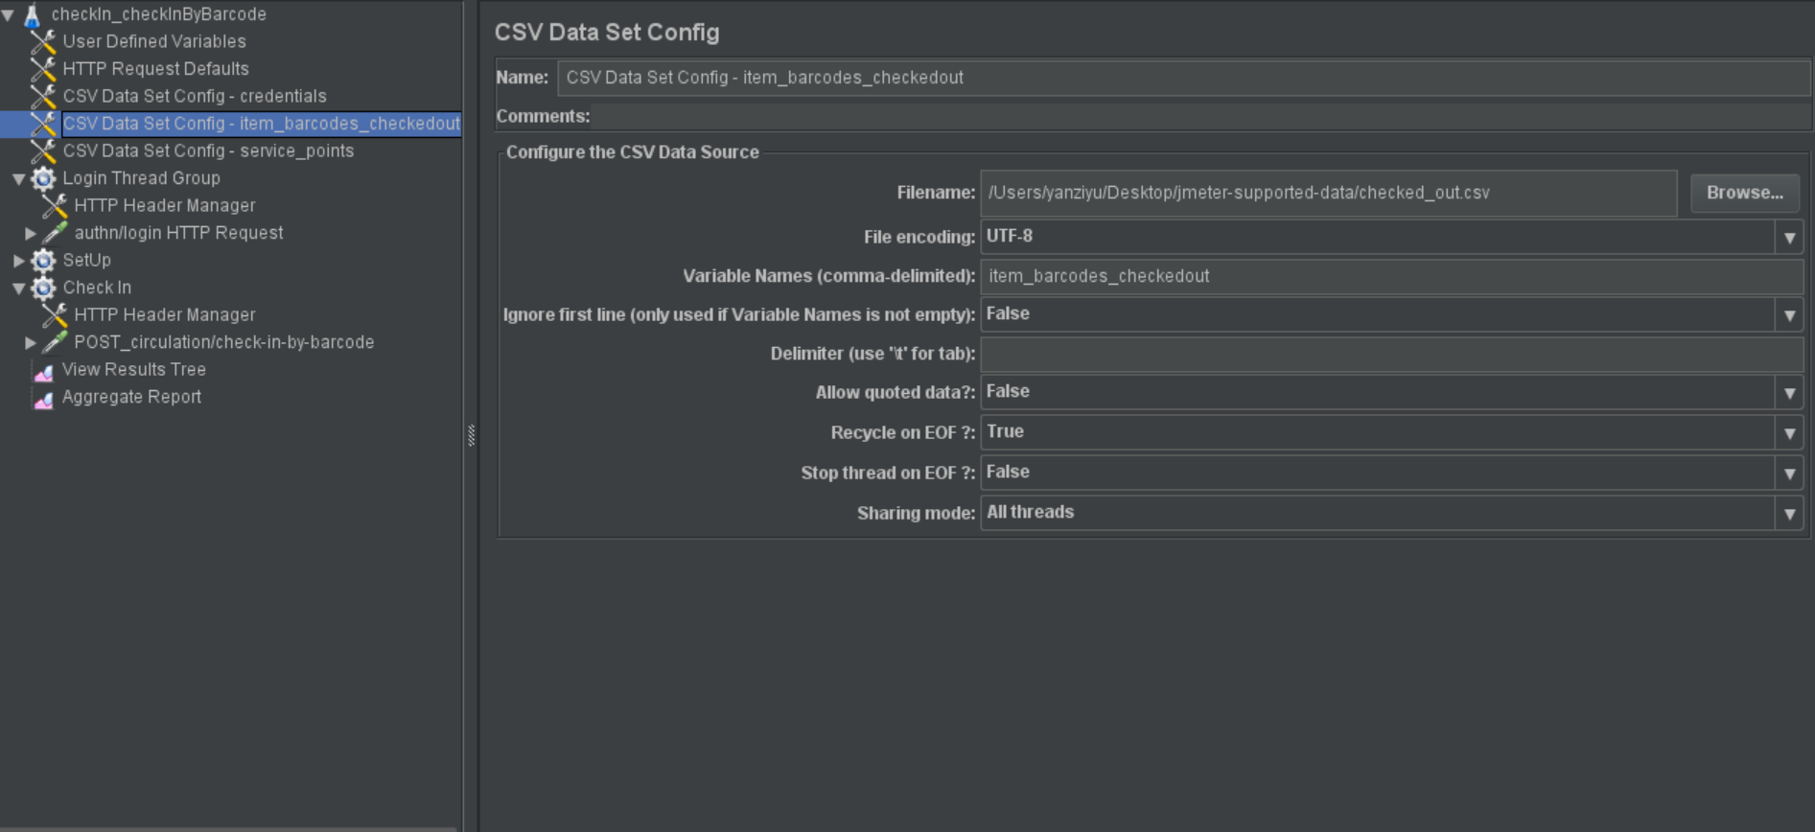
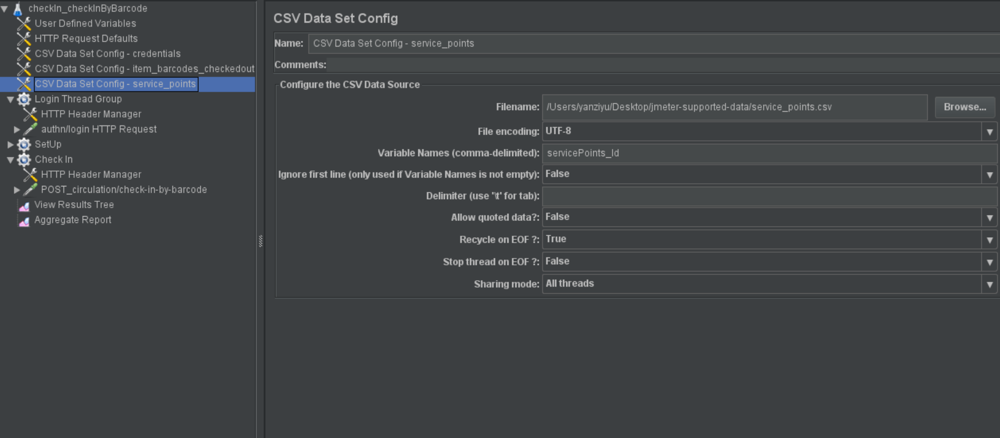
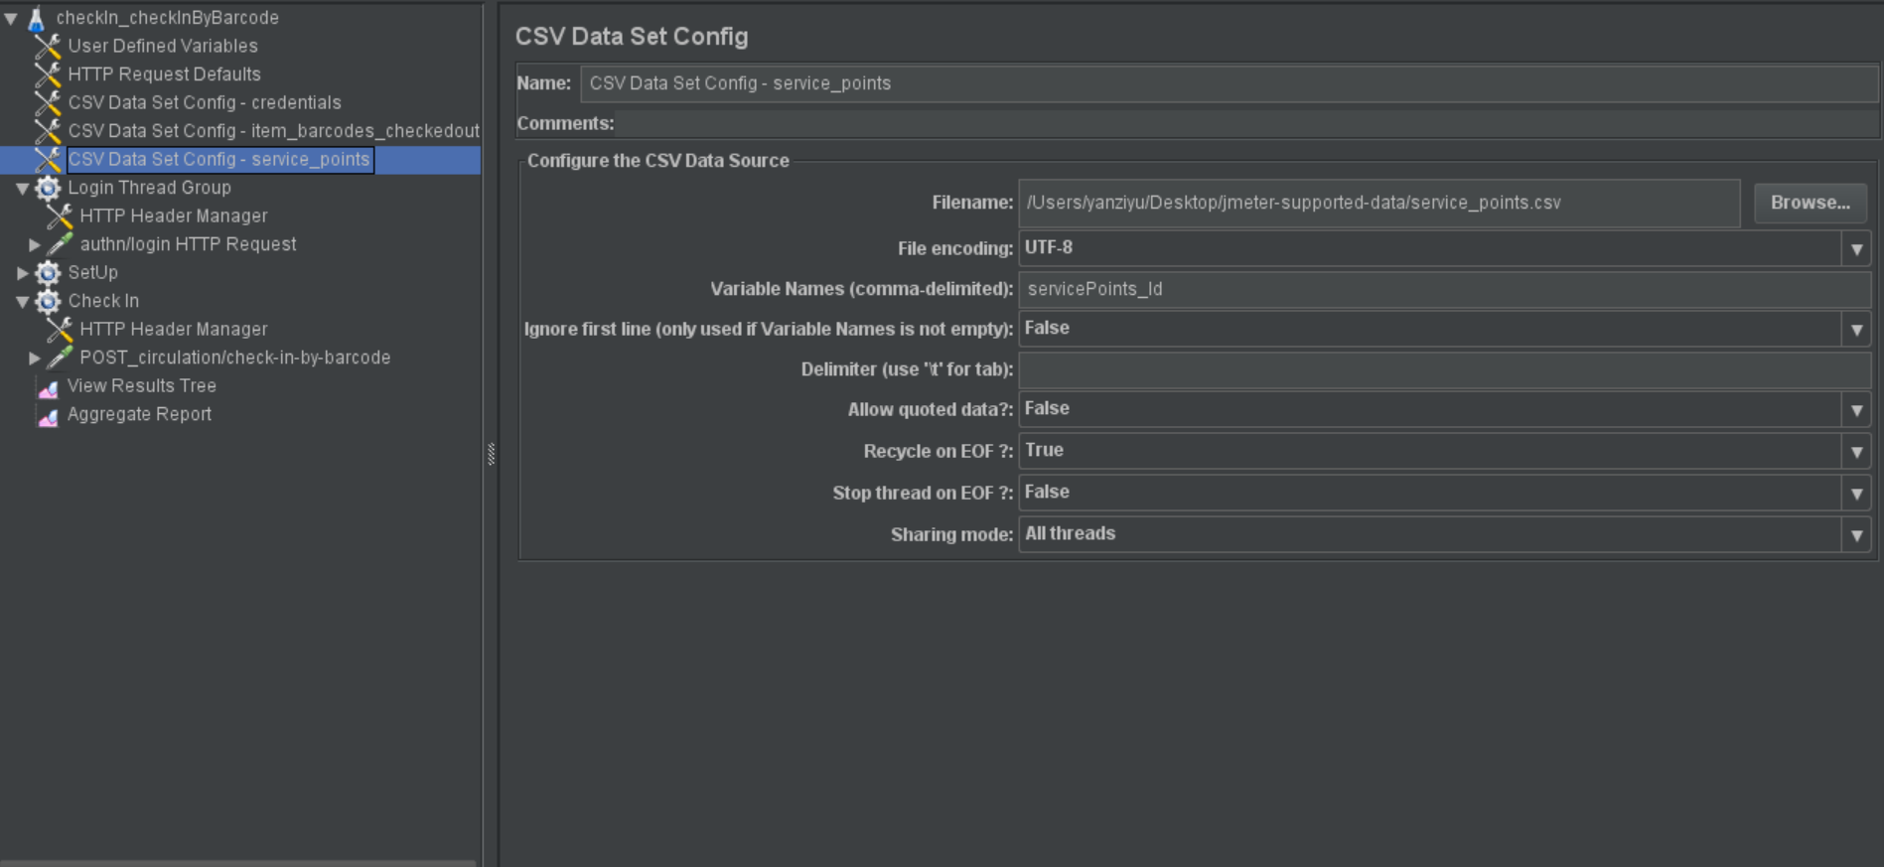
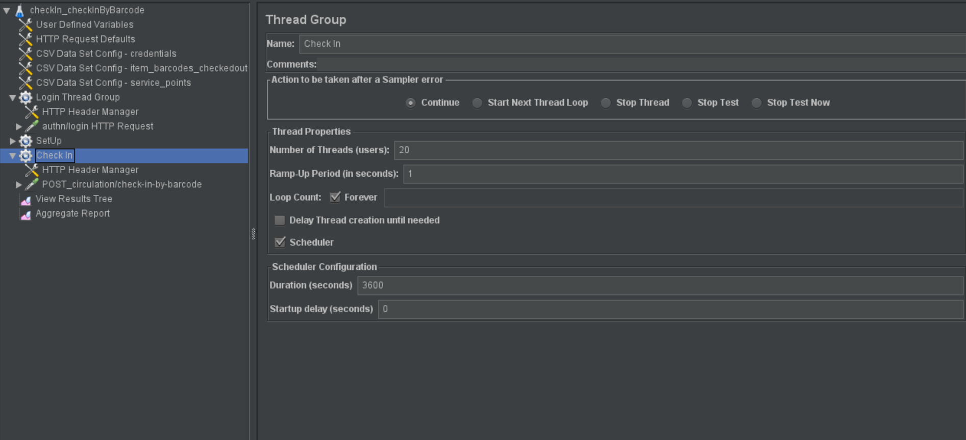
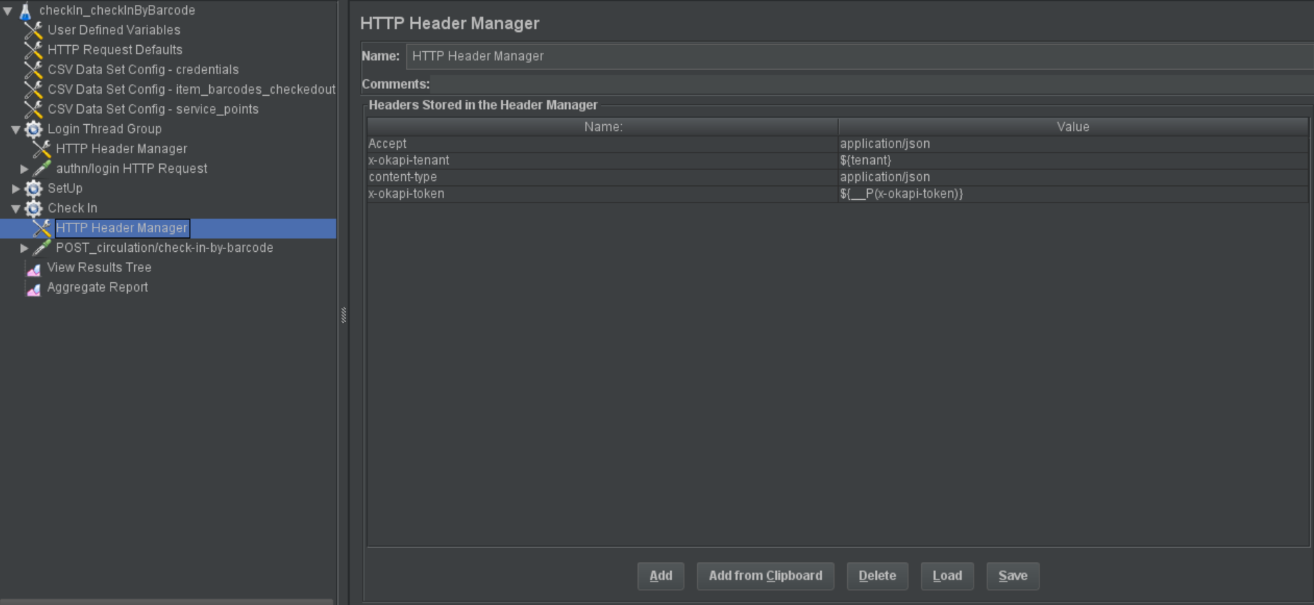
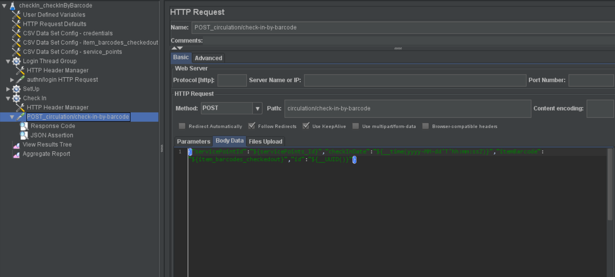

JMeter runs for 30 minutes using 20 threads, and the results obtained by jvm are as follows:
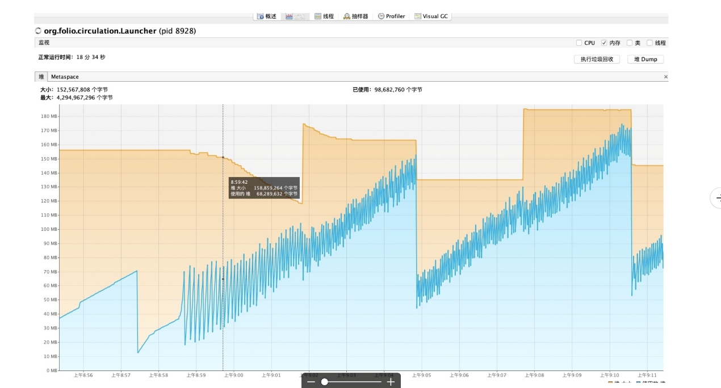
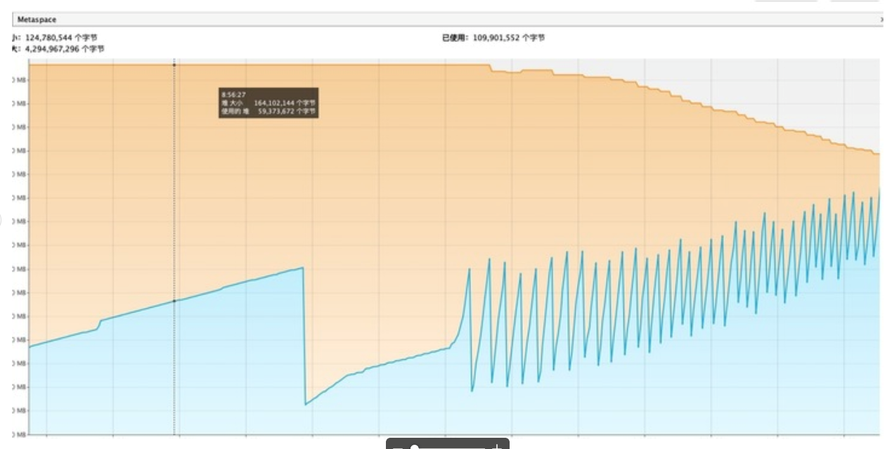
The circulation version used is 18.0.3, and there is no memory leak.

The communication with Martin Tran concluded as follows:
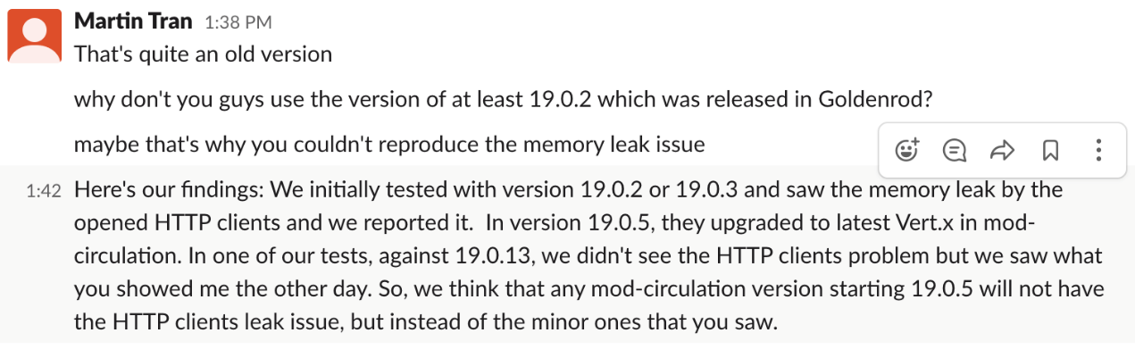
The end result is that there is no memory leak in version 18.0.3, 19.0.13 and 19.0.5, but do appear in version 19.0.2 and 19.0.3. So it should be fixed in version 19.0.5.

