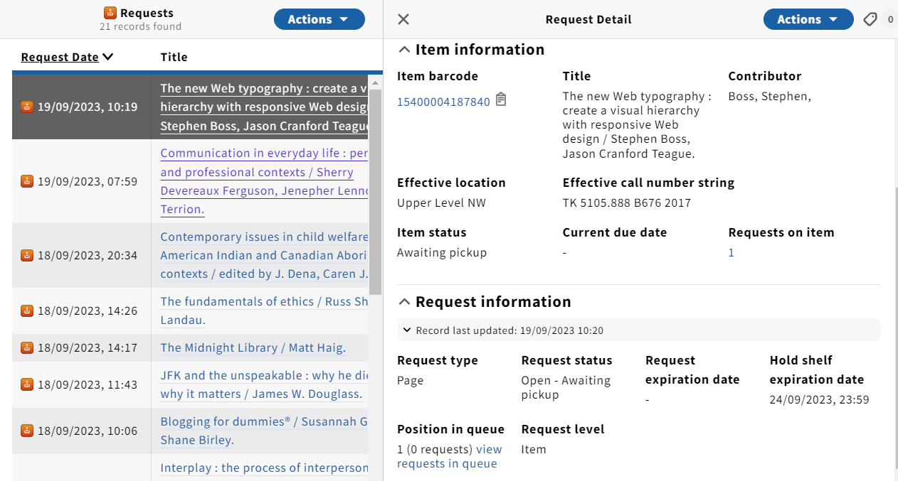

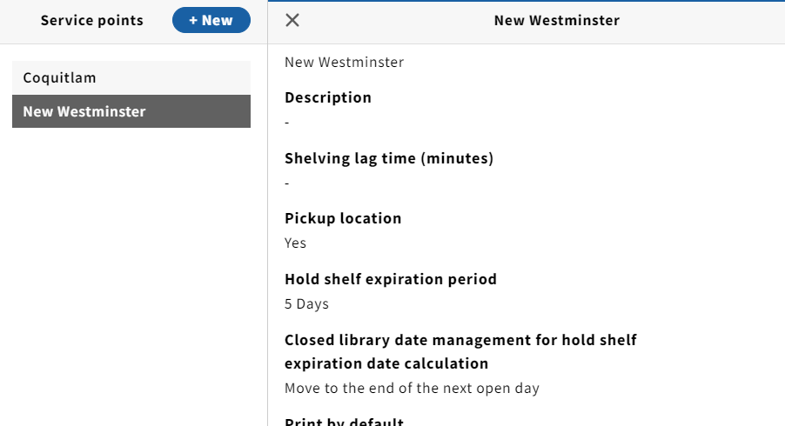

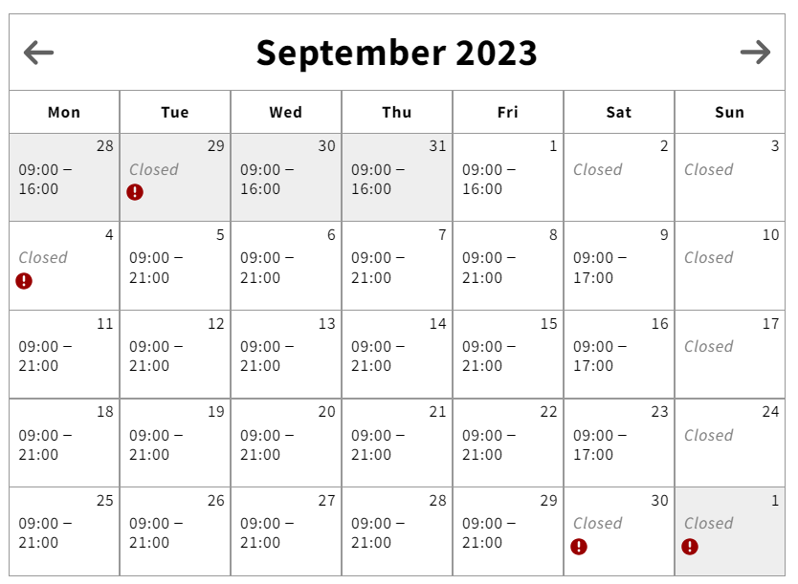

List of requests on our Holdshelf

Request Date Placed on Hold Shelf Title Item barcode Hold shelf exp. date # of days
Wed, 20/09/2023, 20:38 Thu, 21/09/2023 Trust 15400004404609 Tue, 26/09/2023, 23:59 5
Wed, 20/09/2023, 10:30 Thu, 21/09/2023, 10:14 (CO) MIS: management information systems 15400004409525 Tue, 26/09/2023, 23:59 5
Tue, 19/09/2023, 23:36 Wed, 20/09/2023, 7:29 (NW) World War II: a history in documents 15400003866279 Mon, 25/09/2023, 23:59 5
Tue, 19/09/2023, 23:15 Wed, 20/09/2023, 7:29 (NW) Hidden figures: the American dream 15400004185604 Mon, 25/09/2023, 23:59 5
Tue, 19/09/2023, 11:32 Wed, 20/09/2023, 11:13 (CO) The Rosie project 15400004148487 Mon, 25/09/2023, 23:59 5
Tue, 19/09/2023, 10:19 Tue, 19/09/2023, 10:20 (OK) The new Web typography 15400004187840 Sun, 24/09/2023, 23:59 5
Mon, 18/09/2023, 14:26 Tue, 19/09/2023, 10:19 (CO) The fundamentals of ethics 15400004347360 Sun, 24/09/2023, 23:59 5
Mon, 18/09/2023, 10:06 Tue, 19/09/2023, 11:12 (NW) Blogging for dummies 15400003735417 Sun, 24/09/2023, 23:59 5
Fri, 15/09/2023, 21:32 Mon, 18/09/2023, 8:29 (NW) The effects of prison 15400002449176 Mon, 25/09/2023, 23:59 7
Fri, 15/09/2023, 11:26 Mon, 18/09/2023, 10:33 (CO) The trans-Canada writer 15400003985830 Mon, 25/09/2023, 23:59 7
Thu, 14/09/2023, 14:50 Mon, 18/09/2023, 11:04 (NW) Children: a chronological approach15400004106998 Mon, 25/09/2023, 23:59 7
Wed, 13/09/2023, 17:10 Mon, 18/09/2023, 11:03 (NW) Canadian criminal justice 15400004075250 Mon, 25/09/2023, 23:59 7
Fri, 15/09/2023, 13:06 Fri, 15/09/2023, 14:29 (NW) All the light we cannot see 15400004195843 Wed, 20/09/2023, 23:59 5
Thu, 14/09/2023, 10:30 Fri, 15/09/2023, 14:51 (NW) Principles of chemistry 15400004369513 Wed, 20/09/2023, 23:59 5

