Individual user loan screen with overdue items
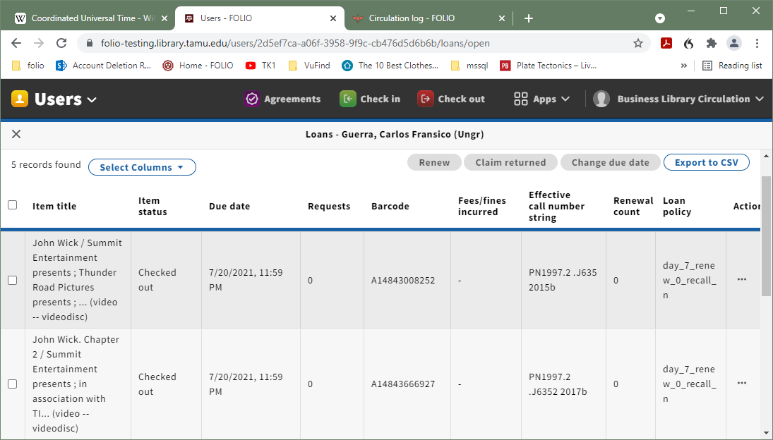

Selection from Overdue loans report showing overdue items checked out to above user. Note that due date is appearing in unconverted UTC.

