Test Environment (测试环境)
- Test Equipment (测试设备)
Device (设备) | Screen Size (屏幕尺寸) | Resolution (分辨率) | Price (价格) | Memory (内存)
Apple ipad air3 | 10.5 inches | 2224*1668 | ￥5065 | 256G

- Test environment (测试环境)：Google Chrome
- Test date (测试时间)：November 24, 2020 (2020年11月24日)
- Test conclusion (测试结论)：Usable, but not user friendly. 可以用但是体验不好

Test Results (测试结果)

User (用户)
- In the “Open Loans” and “Closed Loans” pages, when all the fields are listed in a row, the “Action” button will partially hide. 当前借阅&历史借阅页面，所有字段都放一排时，【操作】按钮会被遮住一部分。
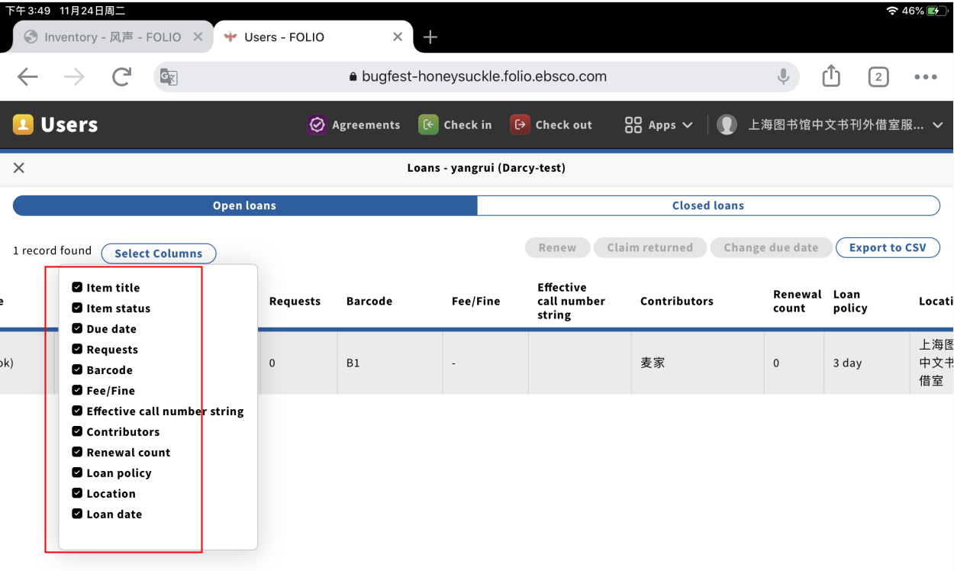
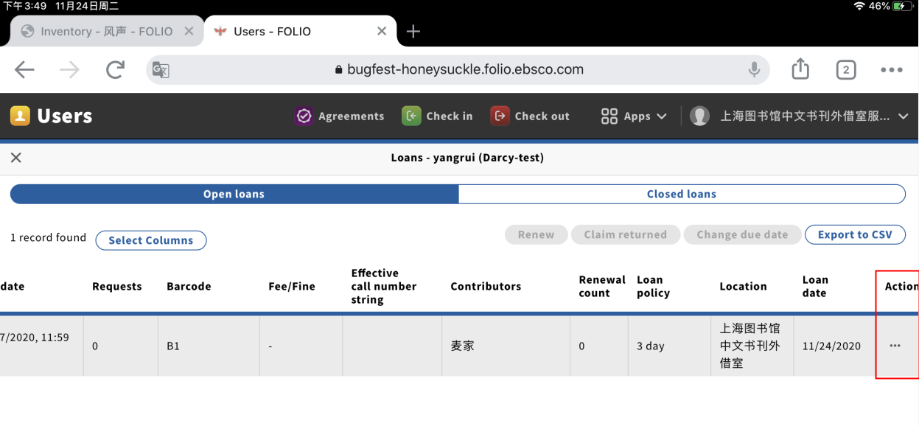

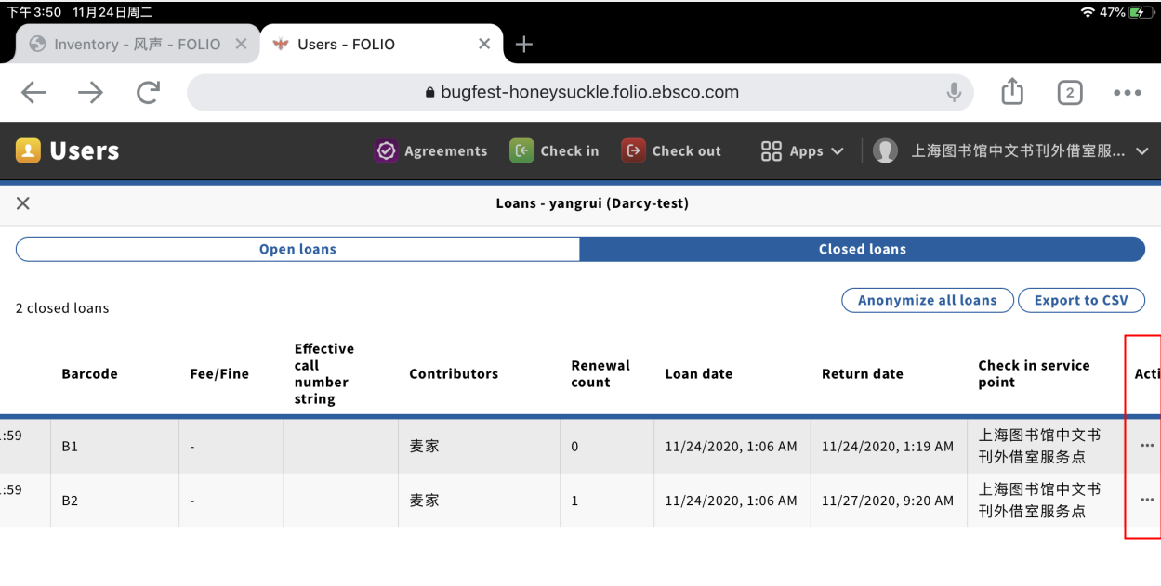
- In the “Closed Loans” page, there will be messy code when click the “Export to CSV” button.历史借阅页面，点击【导出为CSV】按钮，会出现乱码。
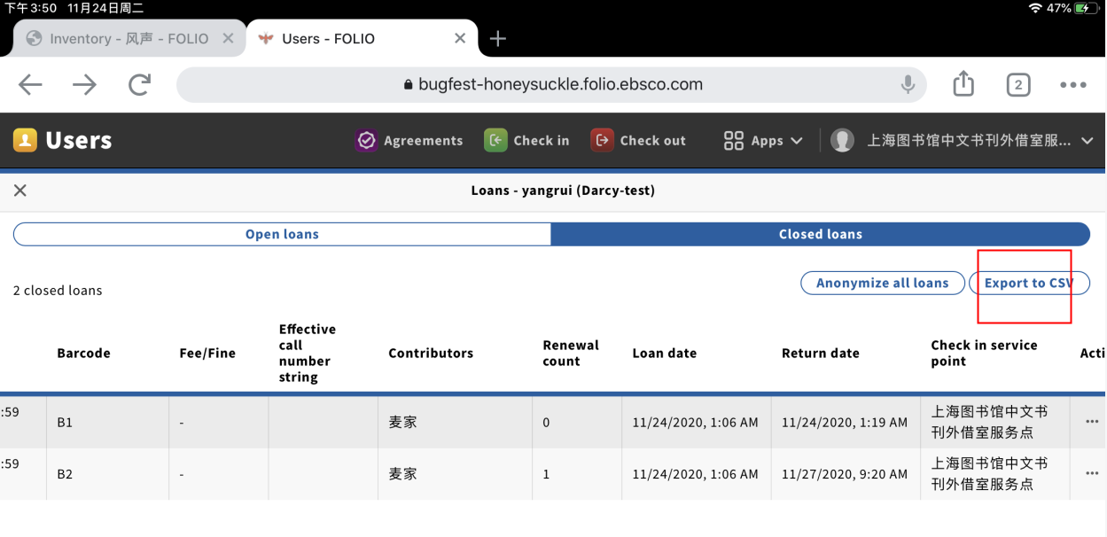
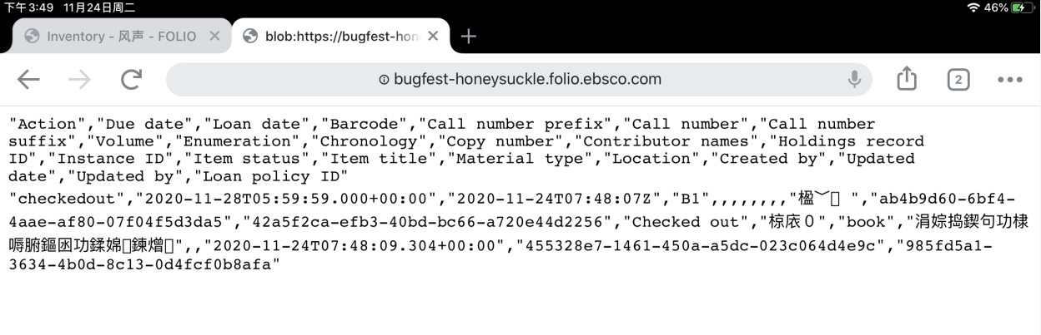

- In the “Open”, “Closed” and “All” pages of Fees/Fines, the “…” button partially hide. 当前&历史&所有费用/罚款费用/罚款页面，【。。。】按钮被遮住一部分。
