Creating a permission set for   
ERM View only

I would like to have a permission set for library staff who should be able to see Agreement, Licenses and eUsage, but not be able to edit in these apps.

I’ve tried to create a permission set with values that seemes appropriate, but using that set returns a number of error messages. I have tried with and without the “Agreements App user” permission, and with and wthout the two “OLF” permissions.

**The newly created “ERM view only” contains:**  
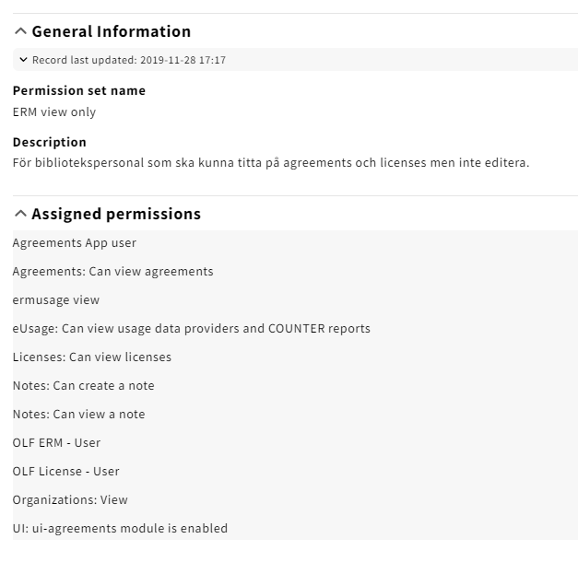

# Error messages

When opening Agreements app these error messages are displayed.

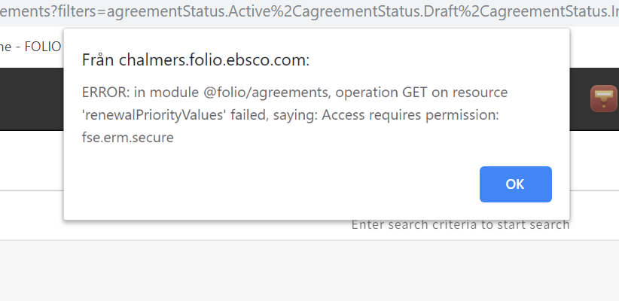

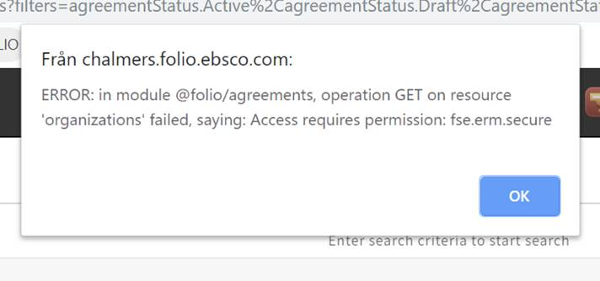

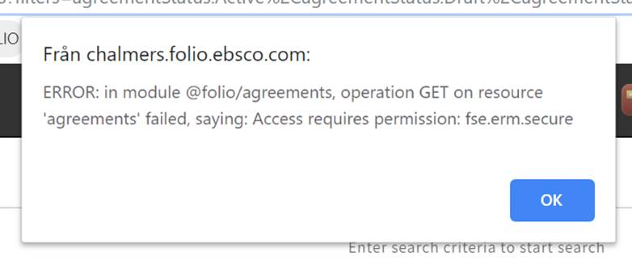

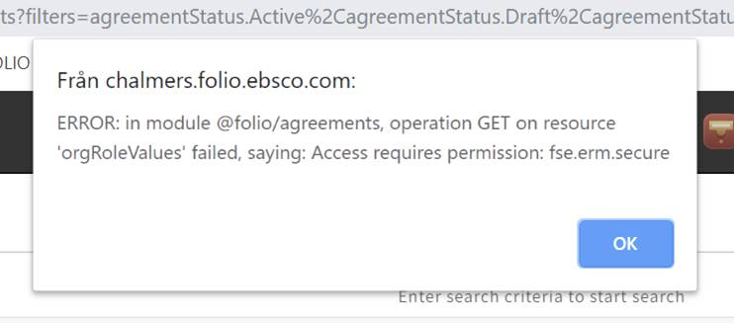

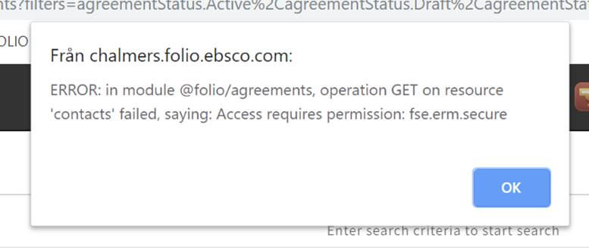

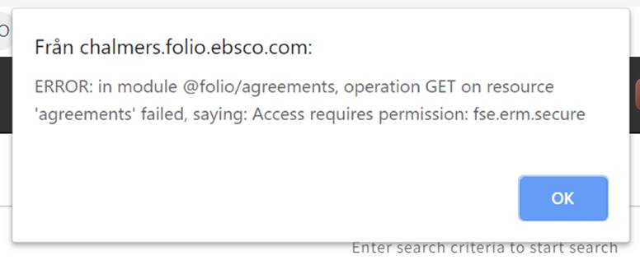

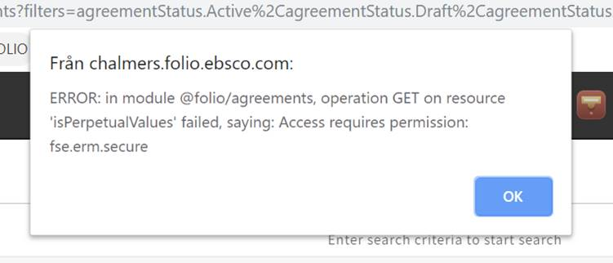

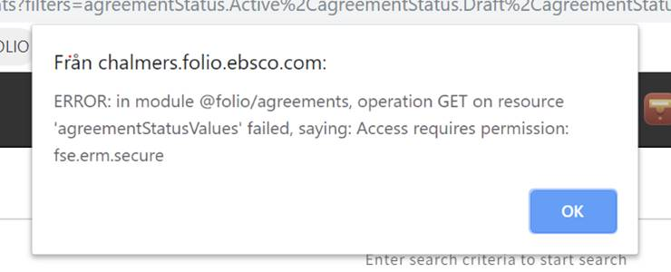

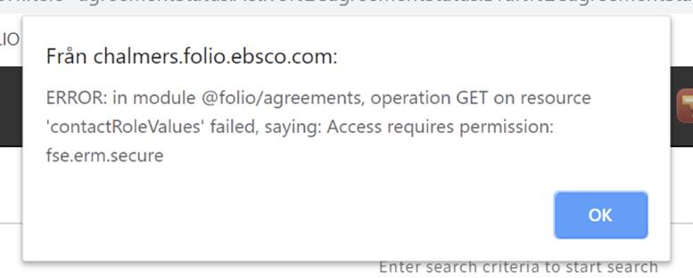

And finally

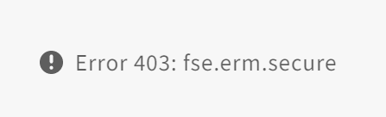

# Additional information

There are also some additional error messages when opening Licenses app.   
Among others, TypeValues and StatusValues  
  
Opening the eUsage app works fine

FYI, the user also has a Circulation permission set that works fine. I’ve also tested with another user that has additional acquisition permissions, with the same results when opening Agreements and Licenses.

