- Single record imported (new); mode of issuance=single unit
Mode of issuance mapped from position 07 of Leader (“m”)
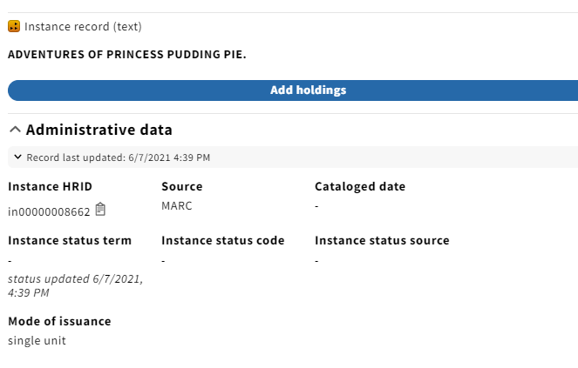
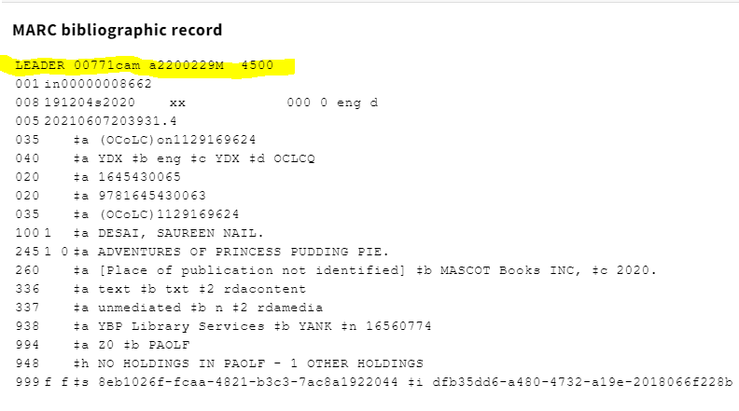

Record overlaid; LDR 07 of imported record = “s”
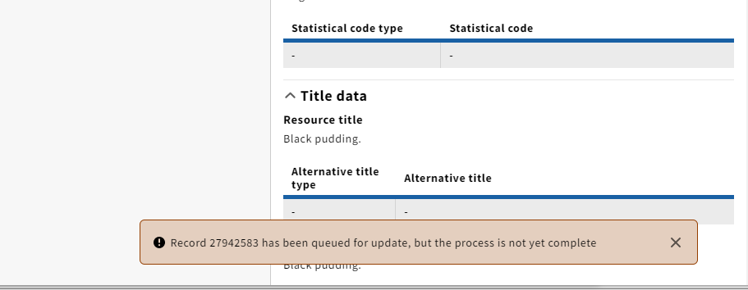

Page refreshed
Record updates display *except* mode of issuance
Part of the leader has been updated, but the “m” should have been changed to “s”

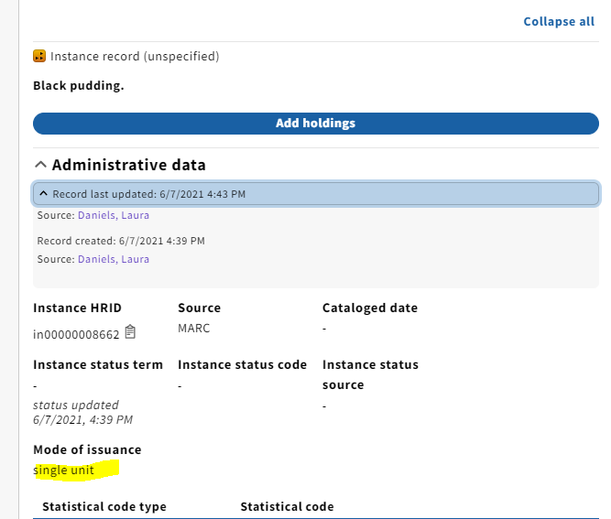
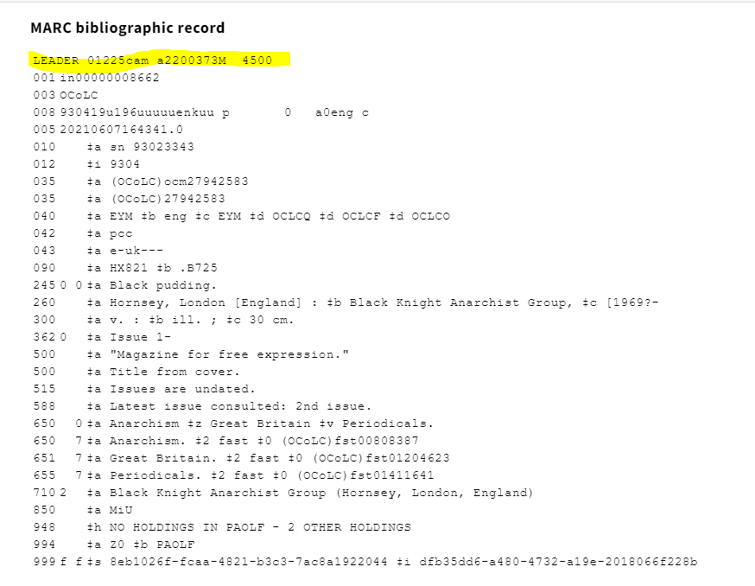
- Record created in FOLIO (non-MARC); mode of issuance=serial
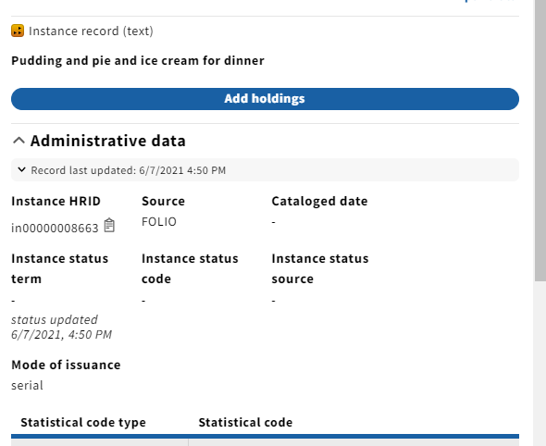

Record overlaid with OCLC record, LDR 07=”m”
Mode of issuance *is* correctly updated to single unit

