Single record imported from OCLC, LDR 07 = m /mode of issuance = single unit
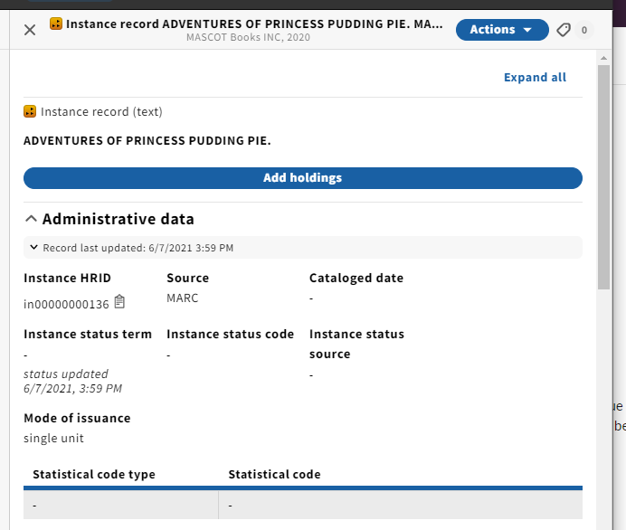
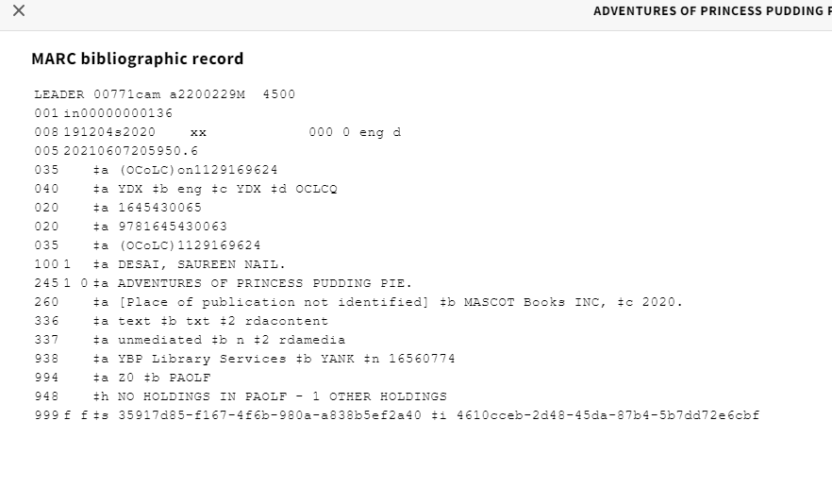
Overlaid with a record with LDR 07=s
Pink success toast:
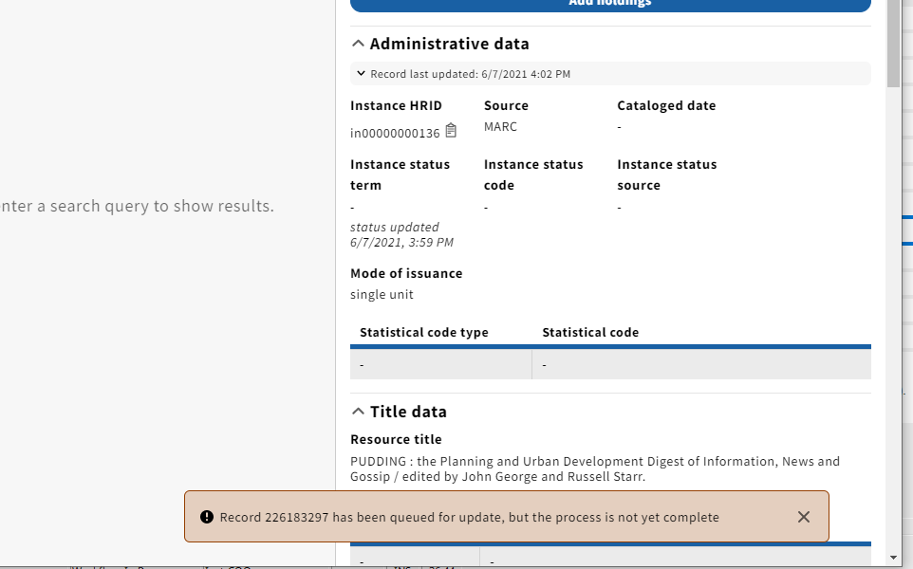

Page refreshed
Other data updated, but mode of issuance still= single unit
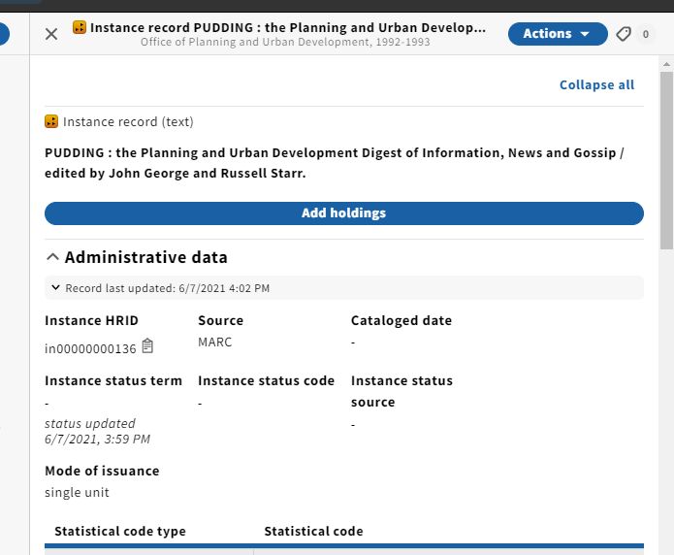
LDR 07 still = m
