Before Deployment of MODINNREACH-324 :
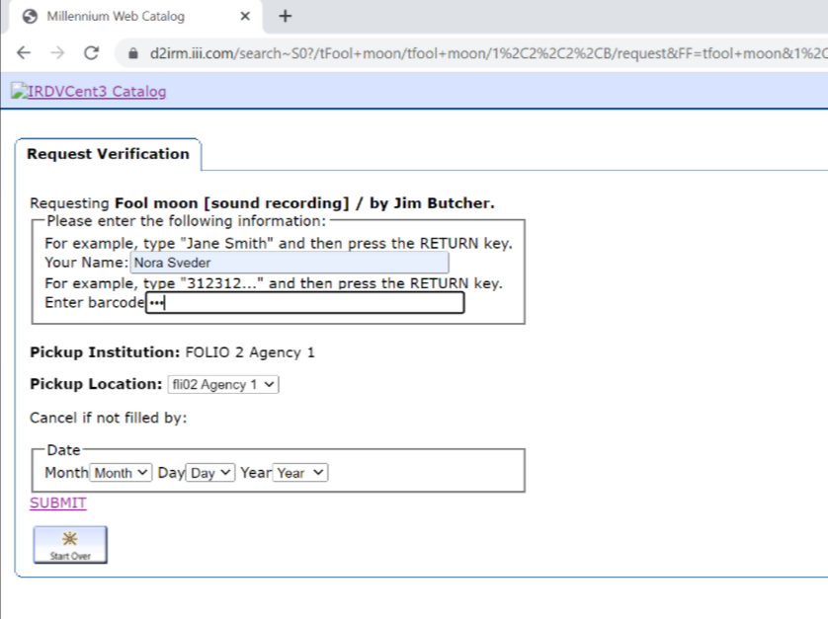

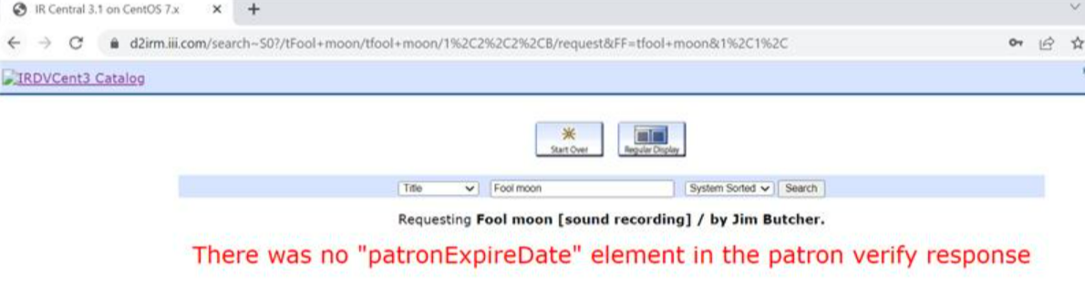

After Deployment of MODINNREACH-324

