MODINNREACH-331
Scenario 1: Current system behavior
Input: Name: Atreides Leto ( lastName Firstname format)
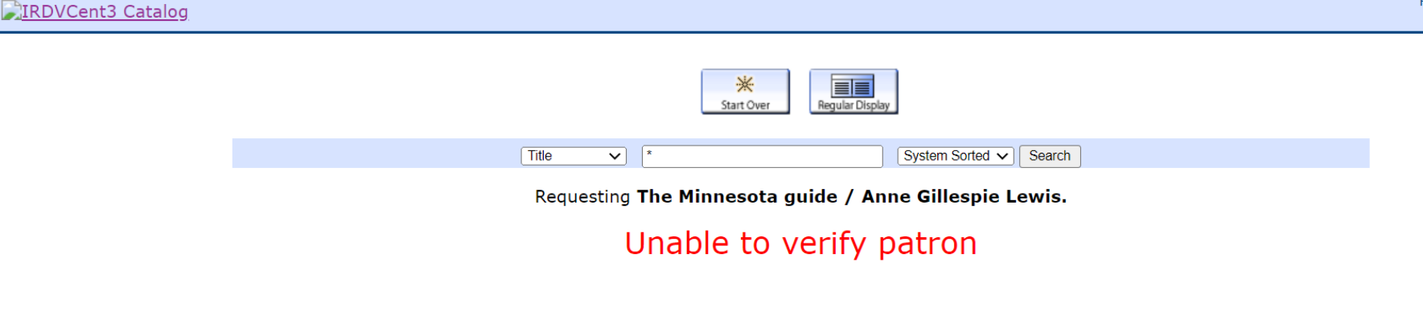

Scenario 2: After deployment of MODINNREACh-331
Input: Name: Atreides Leto ( lastName Firstname format)
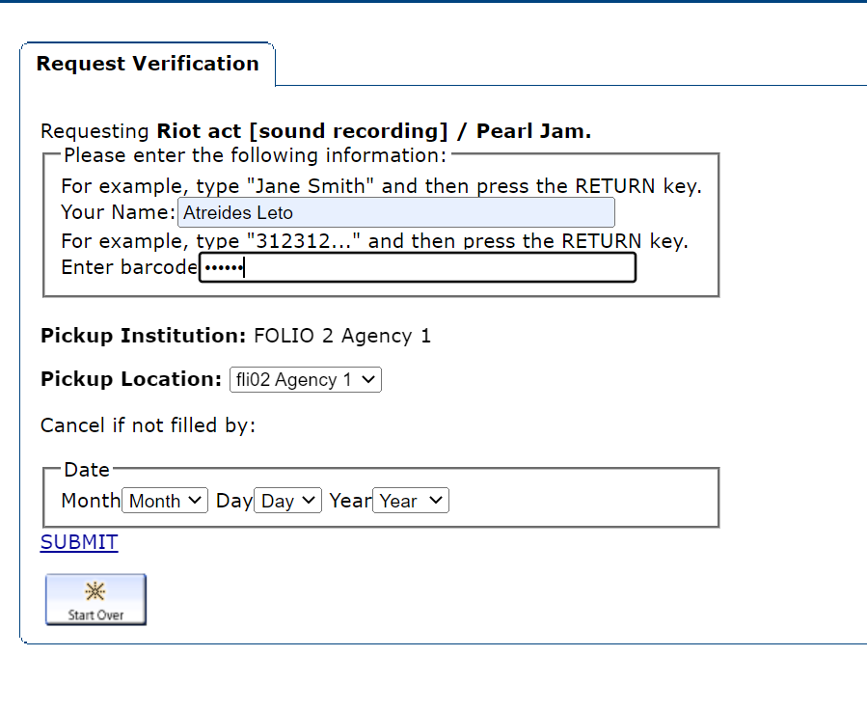
Output:
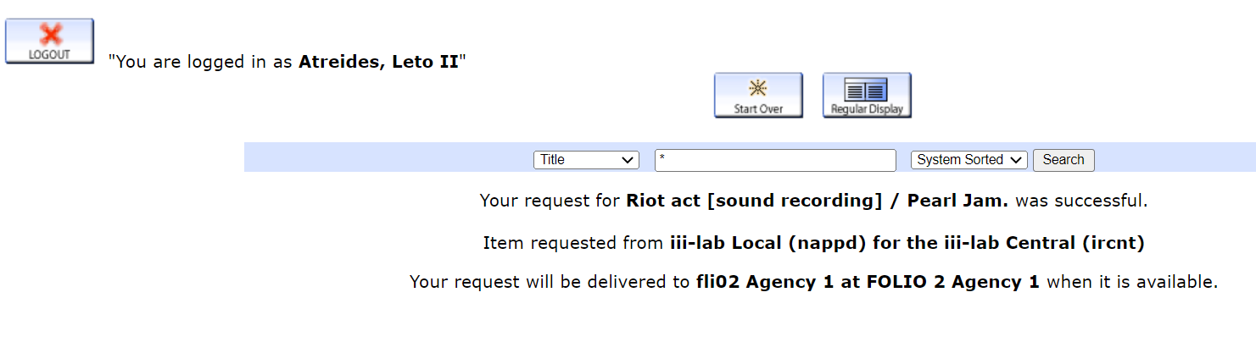

Scenario 3: After deployment of MODINNREACh-331
Input: Name: Leto Atreides (Firstname lastName format)( existing )
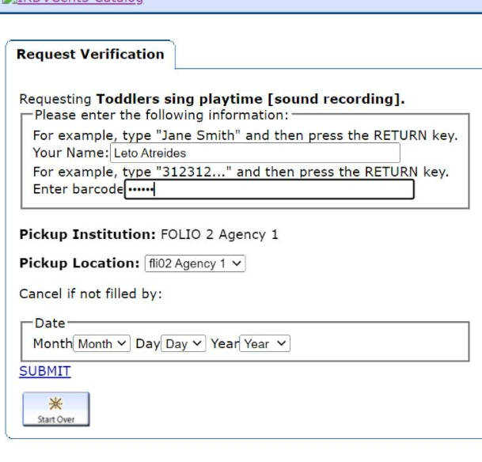
Output :
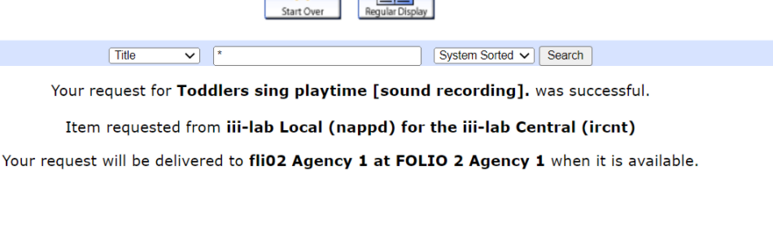
Scenario 4: After deployment of MODINNREACh-331
Input: Name: Error Data
Output:
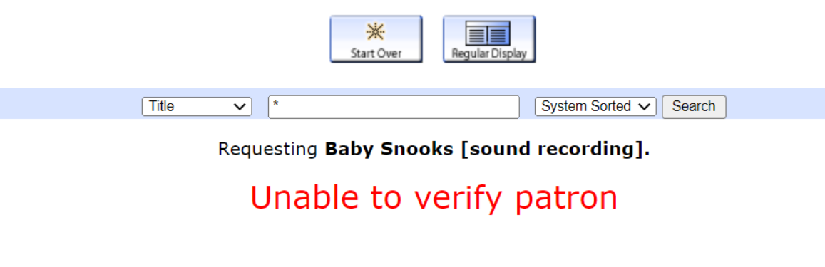

Scenario 5 : After Deployment of MODINNREACH-311
Input : Svoom Liza Test
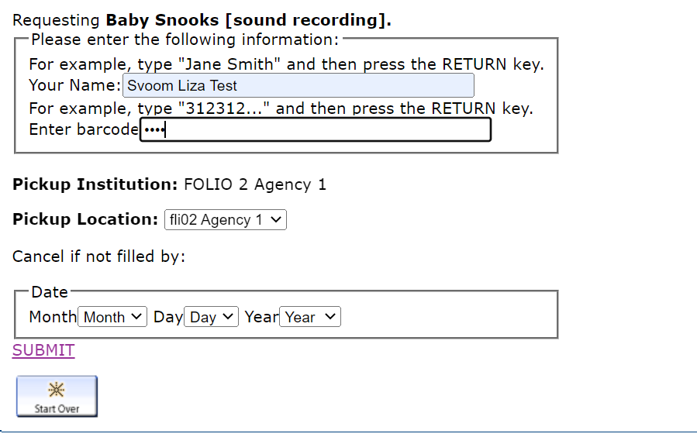

Output:

