- Scenario 1: Last Name First Name case-insensitive format

Input : sveder nora
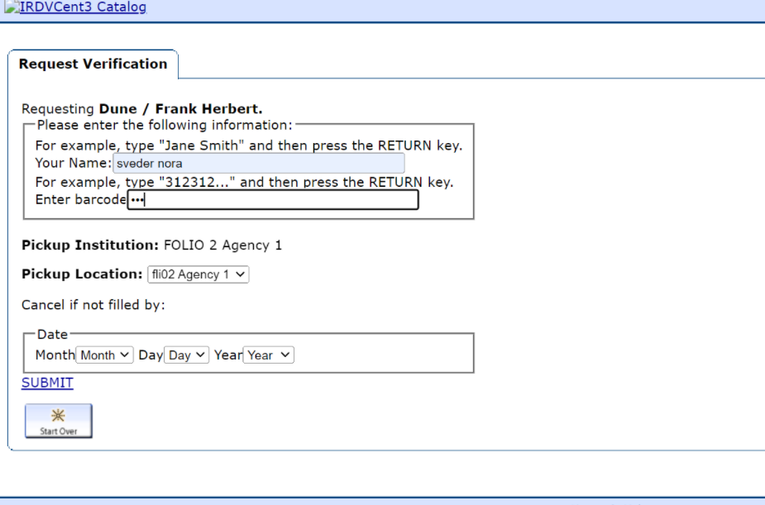
Output:
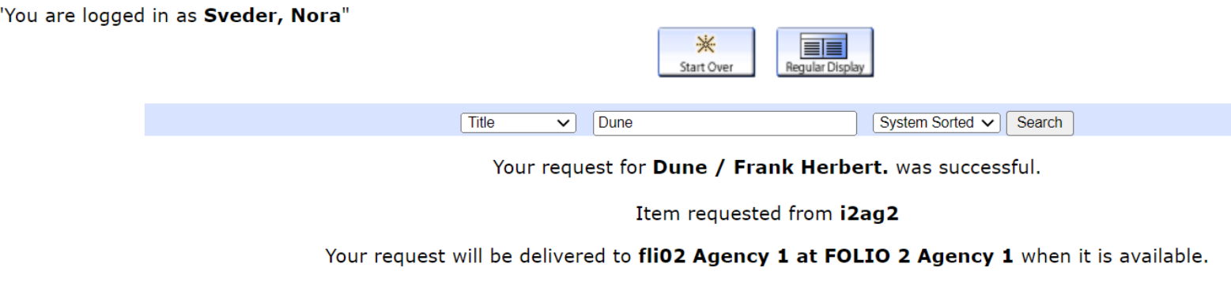

- Scenario 2: Last Name First Name Middle name case-insensitive format

Input : svoom Liza test
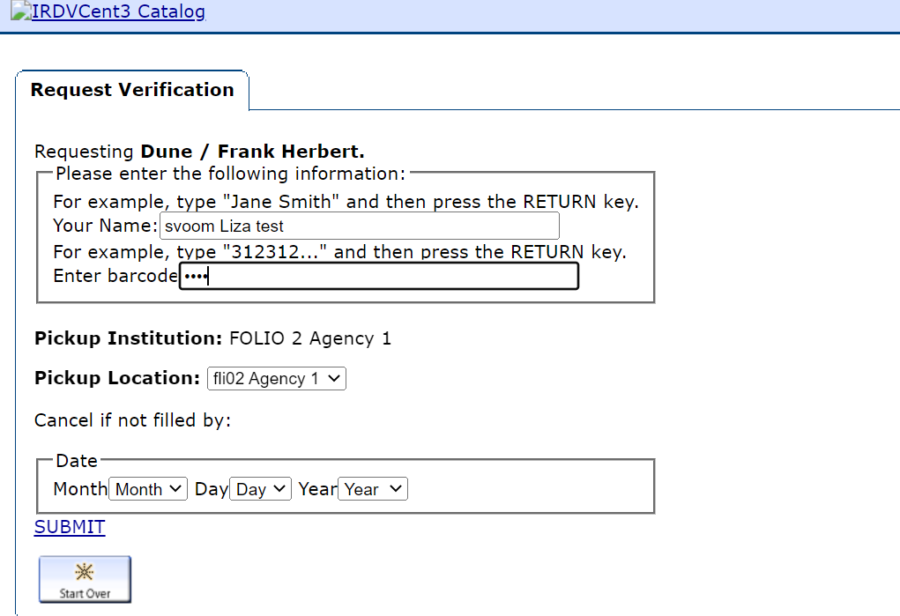

Output :

