Call number browse: tests (works as it should)
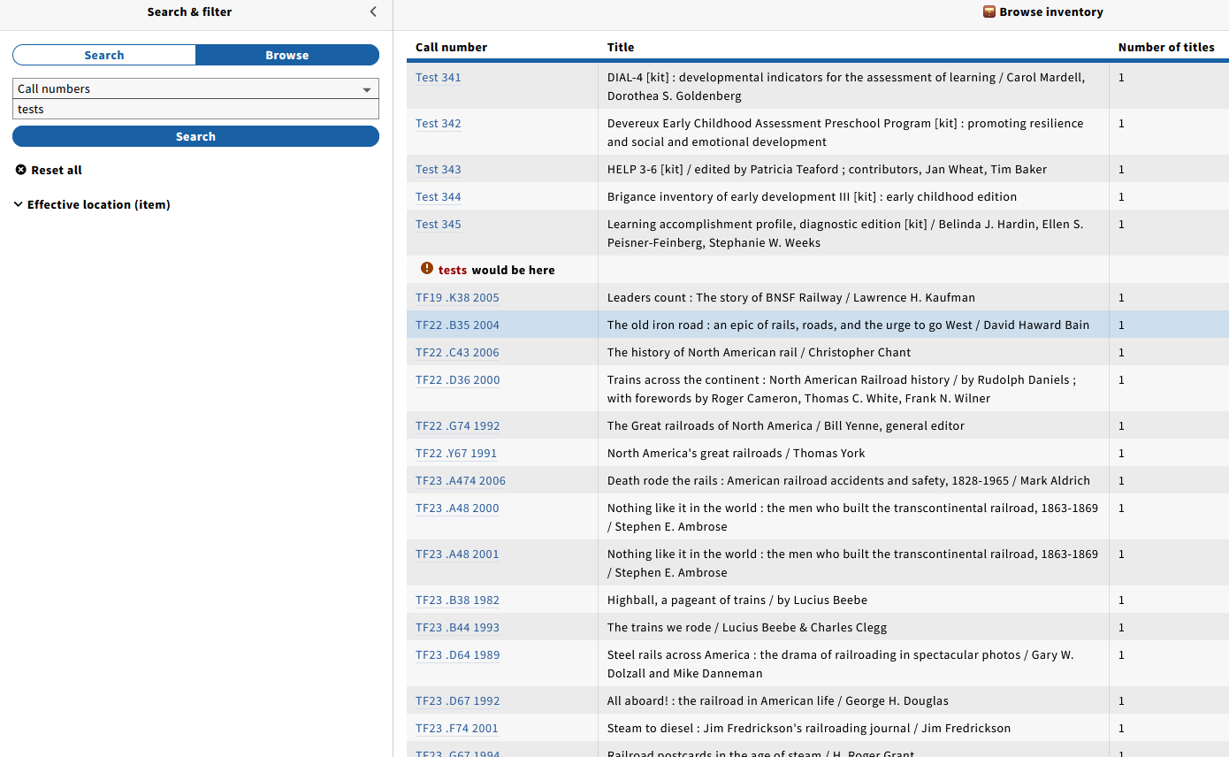

Call number browse: test (no hits returned)

Call number browse: tests, then tried to use the back button to go to the previous page

Call number browse: test, used effective location filter
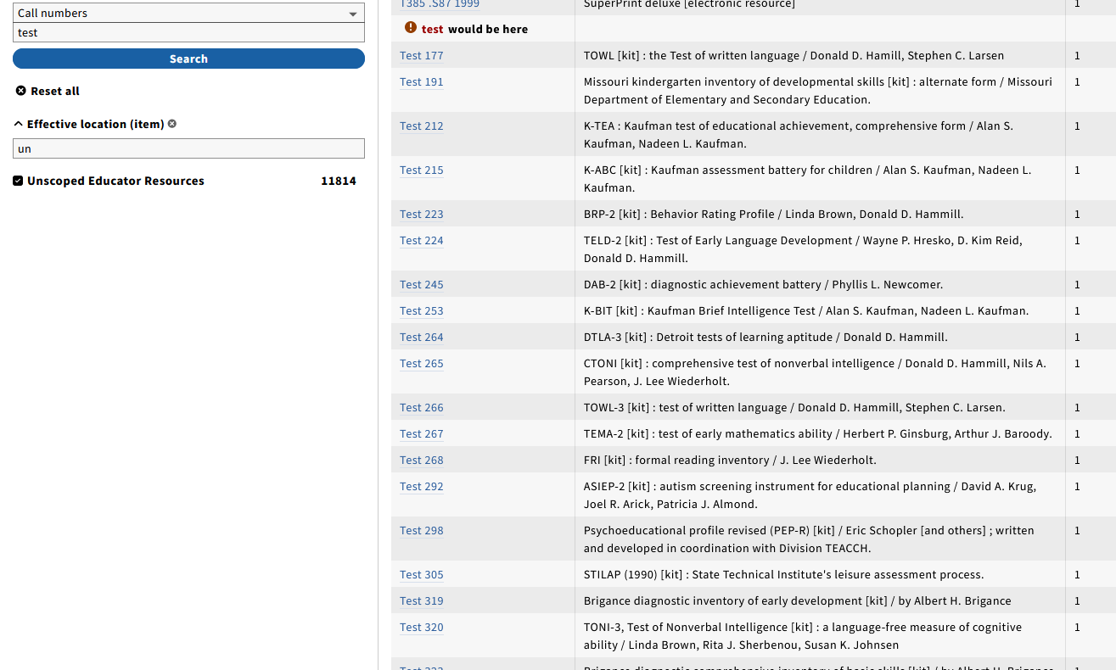

Call number browse: test, used effective location filter (different location)
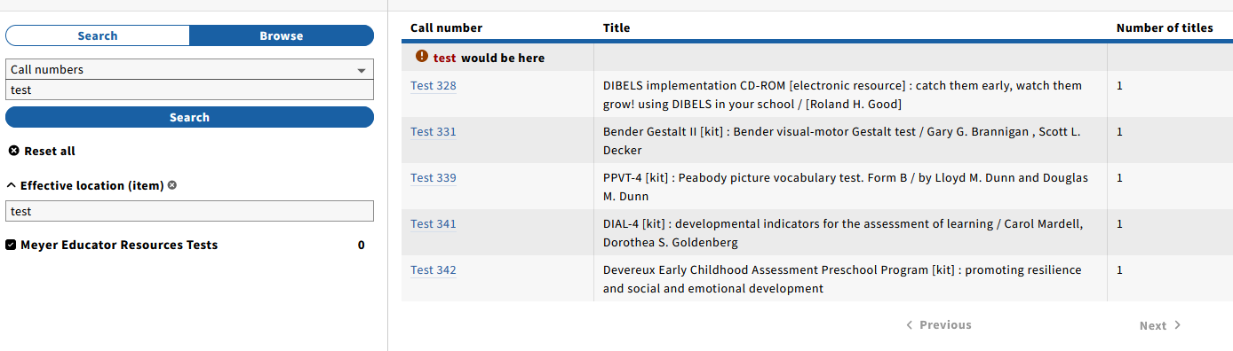
Note: when I first did this search, all of the Tests were in one location, but since then most have been withdrawn. So while using the location filter can be a workaround to force the browse to work correctly, it is not always a viable option, as most of our call numbers are used by multiple locations and it would be impossible to go through them individually (it just happened on this particular example, the call number base was only used in one area). I have also had this happen with LCC and Dewey.
Below are some additional browses that I did in an attempt to get the correct part of the shelflist. These were tried before I thought to use the location filter.
Call number browse: te

Call number browse: td800, then paged using the Next button to try to get to “te” (first page of results)
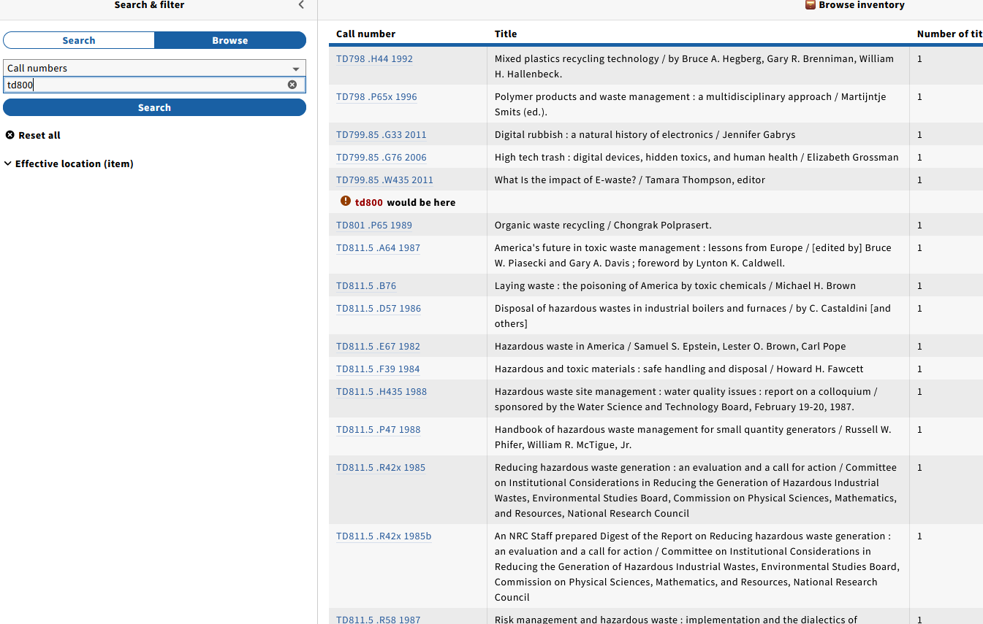
Same search, after I hit the next button
Note: TE is a valid LC call number base. On the TE search, if I use the location filter, I am able to see a list of TE call numbers. On the above search (td800), I also tried td900 hoping it would get me closer to te and therefore less paging, but I got the no results found page (and we have items in the TD900s).

Call number browse: test 338 (not a valid call number)
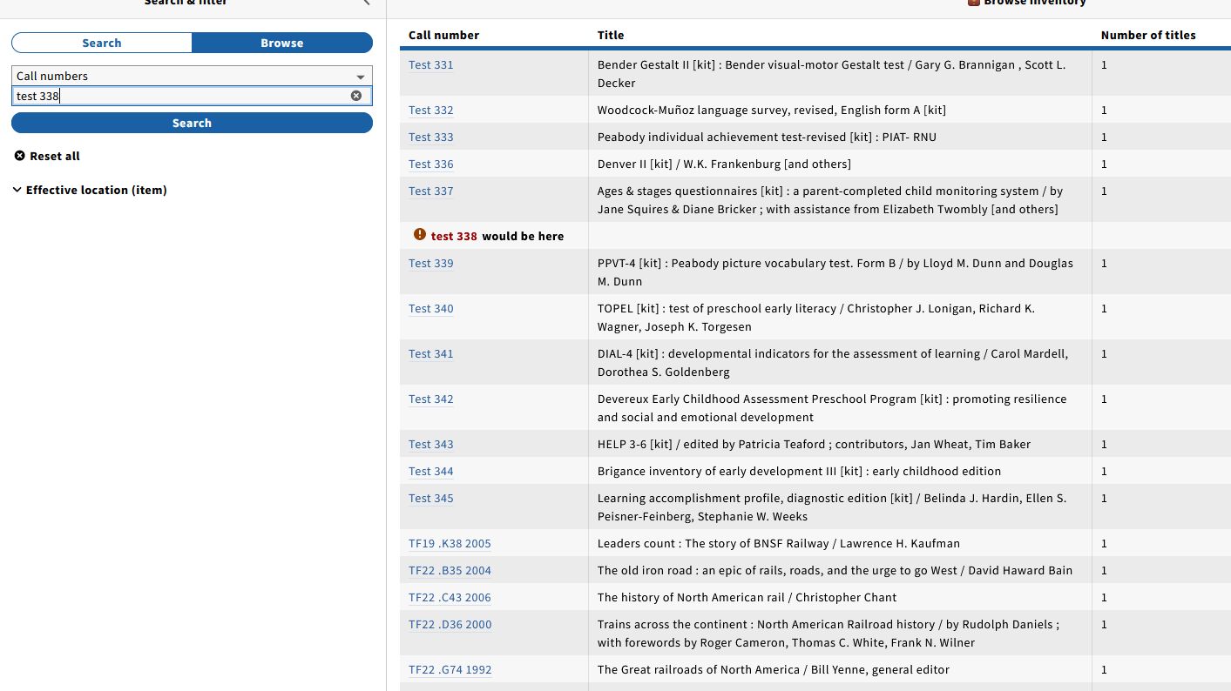
Call number browse: test 341 (exact match)
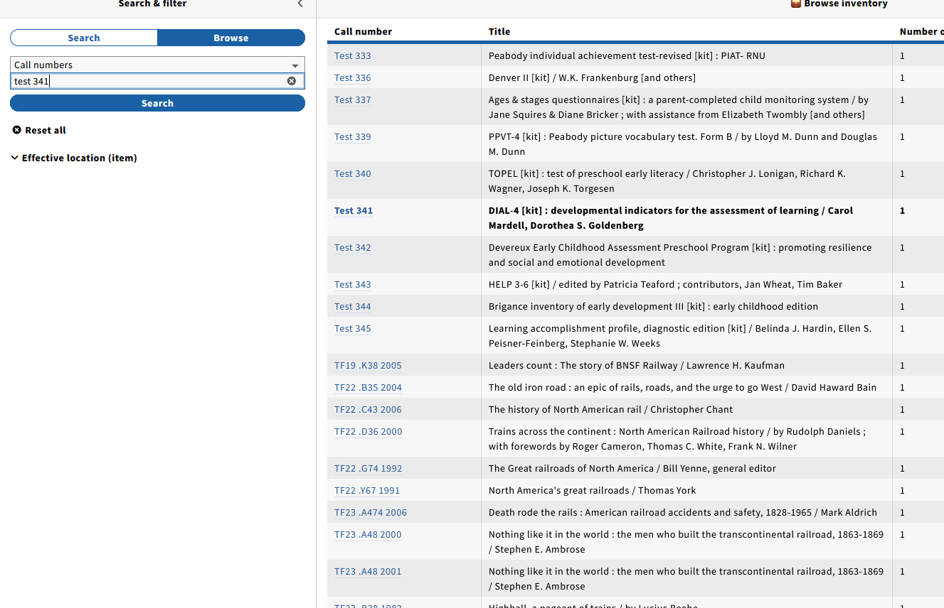
Note: When I did my original search, I did not know any of the specific call numbers, I was just trying to see what we had in our Tests collection. It is actually quite common for me to only search the first/base part of a call number (partly workflow, partly laziness). So I expect the red “your entry would be here” and I’m fine with that. But I don’t think that I should have to put in full call numbers in order to get certain parts of browse list to work correctly.

