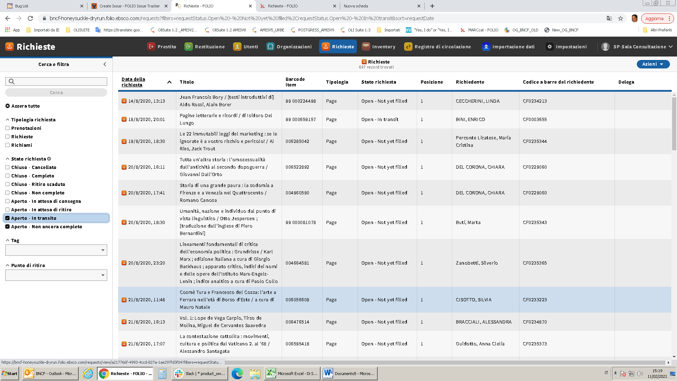

They aren’t traslated

They are wrong