Initial Report and screenshots from Chalmers (Affected Institution)

FOLIO [Important] Request app - No. in "Request queue" column when moving a request is not correct

Here we can see that this item has 5 requests.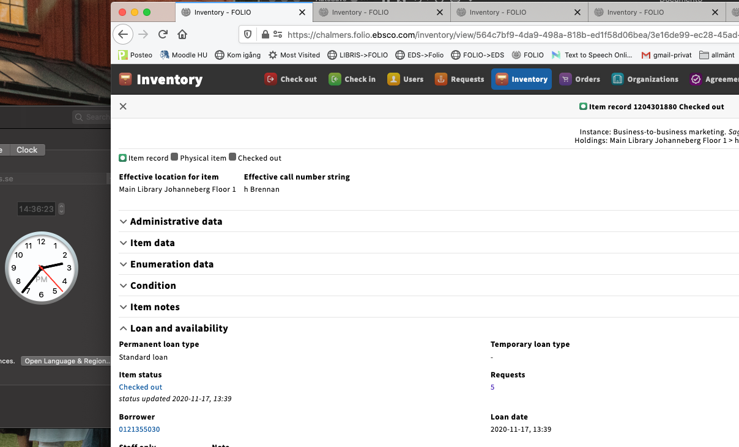
https://chalmers.folio.ebsco.com/inventory/view/564c7bf9-4da9-498a-818b-ed1f58d06bea/3e16de99-ec28-45ad-b5de-7341e307a121/3ca4d00d-2929-40bc-8125-d52dd51889f6

This is the same information we get when we look at all the requests on this instance in the overview. (There are 2 items received and 3 on order for this instance).
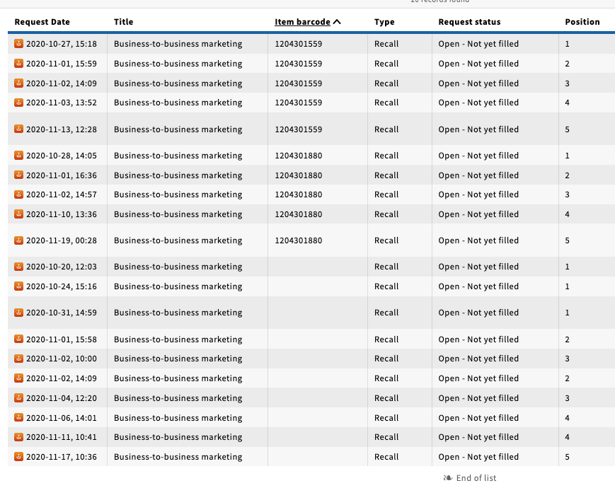
https://chalmers.folio.ebsco.com/requests/view?filters=requestStatus.Open%20-%20Not%20yet%20filled&query=Business-to-business%20marketing&sort=itemBarcode%2CrequestDate

But when we want to move the request from another item, it looks like there is only one request on the example item from above.
This is the same for all five Items from the same instance.
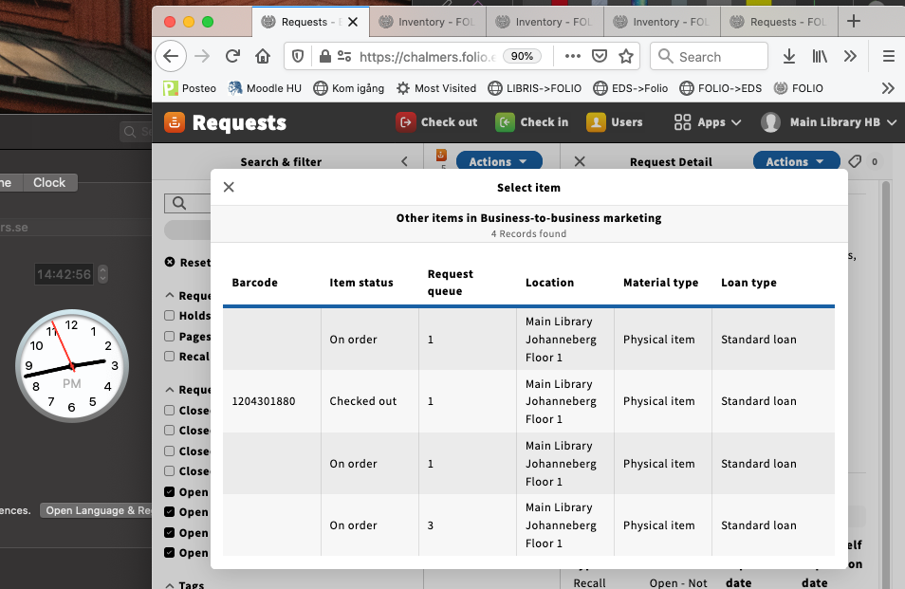
https://chalmers.folio.ebsco.com/requests/view/26fe3405-7229-4560-876d-4e54dc5739d0?filters=requestStatus.Open%20-%20Awaiting%20pickup%2CrequestStatus.Open%20-%20Not%20yet%20filled%2CrequestStatus.Open%20-%20In%20transit%2CrequestStatus.Open%20-%20Awaiting%20delivery&query=f58f6a13-88d5-48fe-88fe-e9e77d53e1a7&sort=Request%20Date

Troubleshooting record:

Goldenrod Bugfest

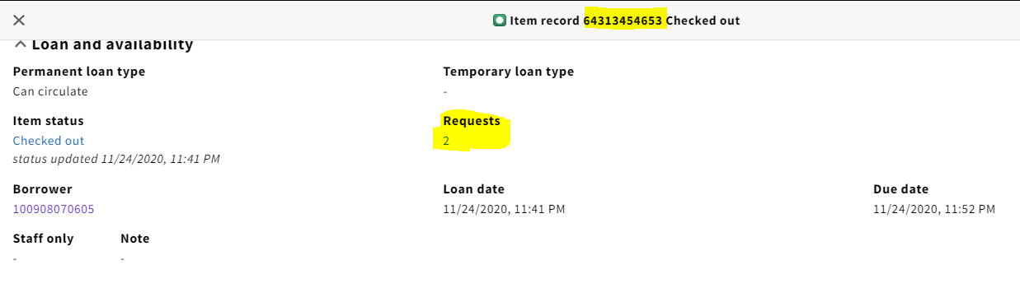
https://bugfest-goldenrod.folio.ebsco.com/inventory/view/c6595944-dea1-47fa-bb19-af539ae63c66/00172736-01c2-4643-a3e6-26b5a84ec999/11b6f48e-9c64-4fa0-86e4-f7cae8a3d81a?query=a%20crack%20in%20the%20spine&sort=title

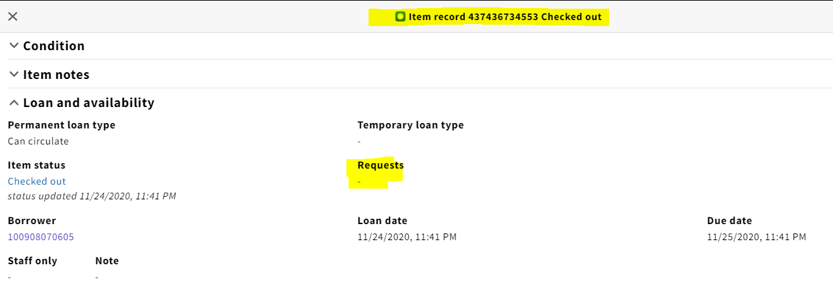
https://bugfest-goldenrod.folio.ebsco.com/inventory/view/c6595944-dea1-47fa-bb19-af539ae63c66/00172736-01c2-4643-a3e6-26b5a84ec999/368166fb-e6b7-49fd-b318-b73d5d9d6310?query=a%20crack%20in%20the%20spine&sort=title

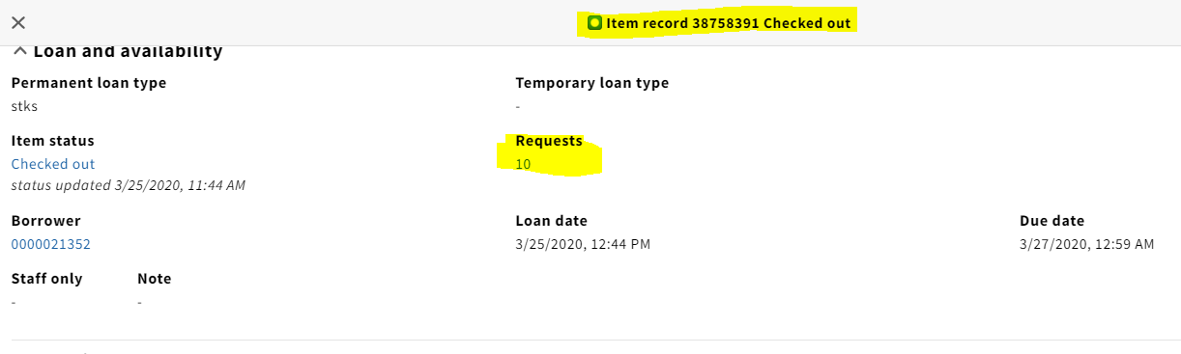
https://bugfest-goldenrod.folio.ebsco.com/inventory/view/c6595944-dea1-47fa-bb19-af539ae63c66/00172736-01c2-4643-a3e6-26b5a84ec999/5a989a84-4c61-4638-a505-9a41c6a3b379?query=a%20crack%20in%20the%20spine&sort=title

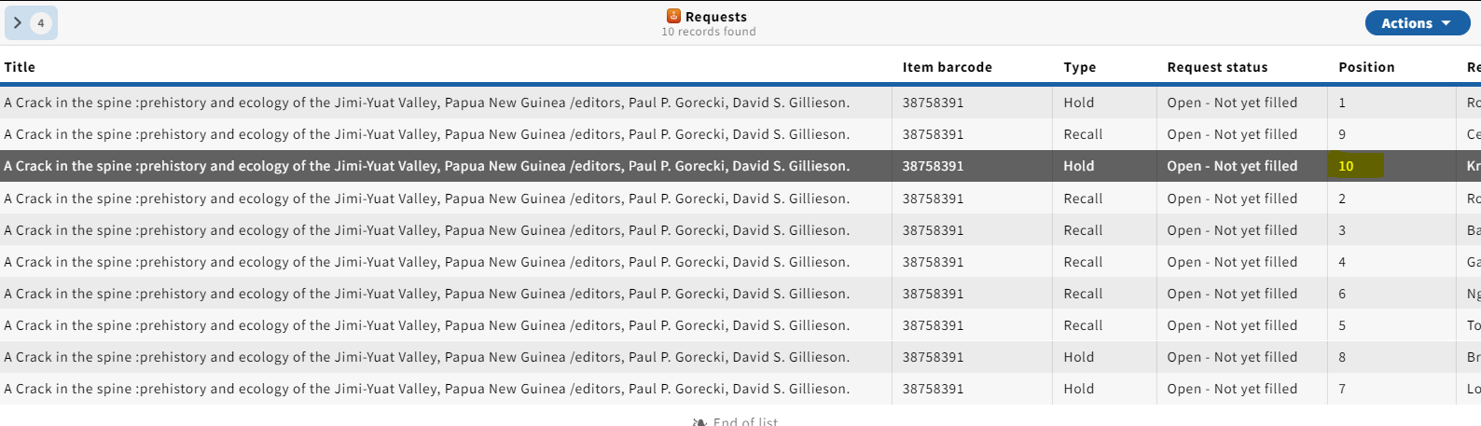
https://bugfest-goldenrod.folio.ebsco.com/requests/view/b9aa0876-fd0d-444b-a950-c59e9ce00e85?filters=requestStatus.Open%20-%20Not%20yet%20filled%2CrequestStatus.Open%20-%20Awaiting%20pickup%2CrequestStatus.Open%20-%20Awaiting%20delivery%2CrequestStatus.Open%20-%20In%20transit&query=38758391&sort=Request%20Date

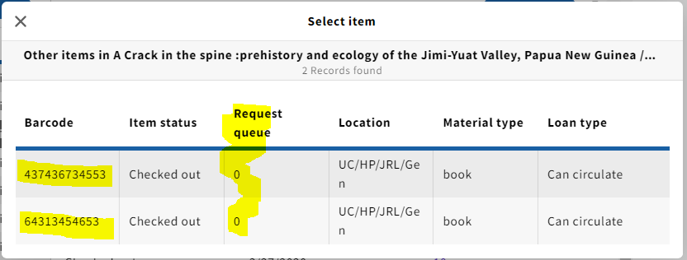

Honeysuckle Bugfest

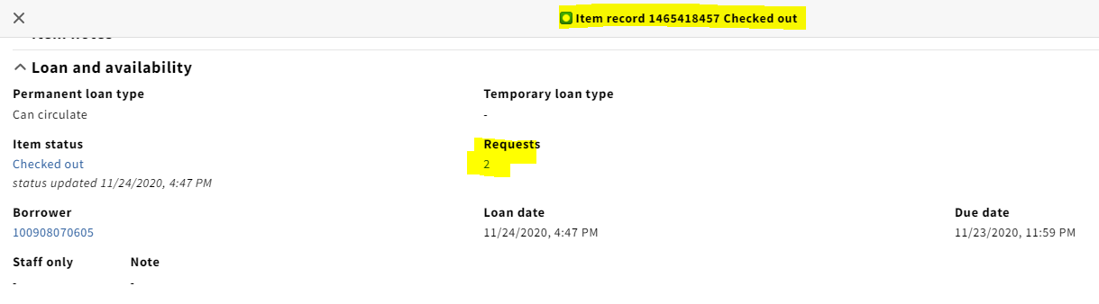
https://bugfest-honeysuckle.folio.ebsco.com/inventory/view/c6595944-dea1-47fa-bb19-af539ae63c66/00172736-01c2-4643-a3e6-26b5a84ec999/024cbfad-0924-4bbe-8046-e460023cc78c

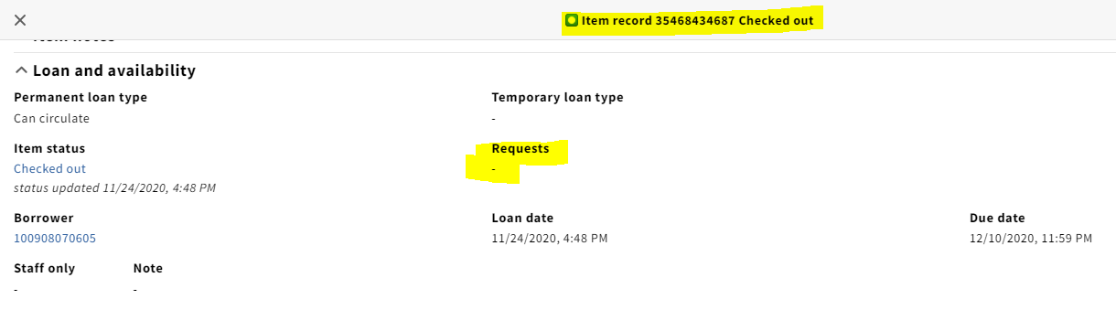
https://bugfest-honeysuckle.folio.ebsco.com/inventory/view/c6595944-dea1-47fa-bb19-af539ae63c66/00172736-01c2-4643-a3e6-26b5a84ec999/761246d7-fb40-484b-b20e-7bb2904b1d8e

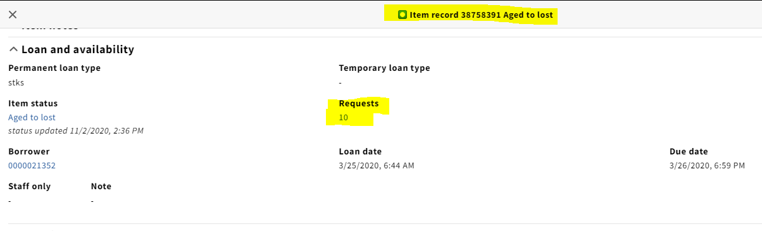
https://bugfest-honeysuckle.folio.ebsco.com/inventory/view/c6595944-dea1-47fa-bb19-af539ae63c66/00172736-01c2-4643-a3e6-26b5a84ec999/5a989a84-4c61-4638-a505-9a41c6a3b379

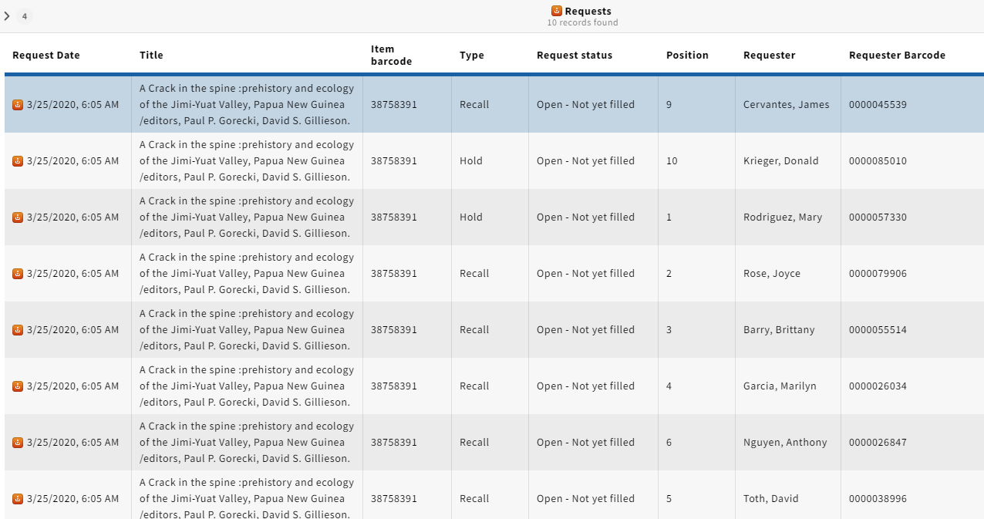
https://bugfest-honeysuckle.folio.ebsco.com/requests/view/b9aa0876-fd0d-444b-a950-c59e9ce00e85?filters=requestStatus.Open%20-%20Not%20yet%20filled%2CrequestStatus.Open%20-%20Awaiting%20pickup%2CrequestStatus.Open%20-%20Awaiting%20delivery%2CrequestStatus.Open%20-%20In%20transit&query=5a989a84-4c61-4638-a505-9a41c6a3b379&sort=Request%20Date

