FOLIO [Medium]

Orders and receiving - want to see that an order is closed in result list
Chalmers Goldenrod dry run as of 2020-10-13 / Marie Widigson
Use case:
I search for a title or ISBN to receive an order.
I want to quickly determine wich order line to receive on
In Order lines result list and in Receiving result list, I have to click through to see that an order is closed.
One of the order lines below is Closed – cancelled, but I cannot easily see which one.
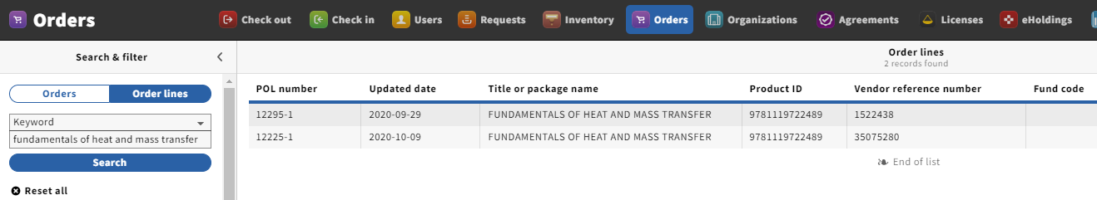
The same applies to the Receiving result list.
