Managing headings in WeCat
There are several ways to add, modify and delete headings in WeCat:
- Working on the index
- Working on the cataloging worksheet
- Working on the authority item worksheet

- WORKING ON THE INDEX
To work on the index, from the Main Search window scan for the entry you wish to add.
You can SCAN the following fields:
- Name (Person, Corporate, Meeting)
- Title
- Name/Title
- Publisher (Name and/or Place)
- Subject
- Classification
- Control number
- Shelf list
So, type the Index code (i.e. NA for Name) + the search string.
NA Jones, Leslie + SCAN
Fig.1.
If the heading is already present the system will display it in second position of the index of Names. The heading is not present in the catalogue, so I create a new one selecting “New heading”
Fig.2.
Fig.3.
I can add other subfields selecting “Add subfield” button or enter directly the string with all subfields using the “Quick insert” function

The name heading “Jones, Leslie” will be added to the index of Names and it is a “zero heading”, that means the heading hasn’t any association with bibliographic and/or authority records, but it could be used, then, during a cataloguing of a record (bibliographic and/or authority).
Fig.4.
This heading is saved in a specific table (oracle or postgres db), called NME_HDG, with a name heading number: 82852
Fig.5.
NME_HDG TABLE (columns)
NME_HDG_NBR | 82852 | Identification number assigned to the heading name
USR_VW_IND | 1000000000000000 | User view 1 where the heading is saved (used to indicate the catalog of the library)
HDG_AUT_CNT | 0 | Value to indicate if this heading name is linked to an authority record (if the value is >=1, it will means that there are one or more authority records with that heading name)
NME_HDG_TYP_CDE | 2 | Type code name (to indicate Personal, Corporate or Meeting )
NME_HDG_SUB_TYP_CDE | 3 | Type code to indicate the first indicator of tag 1XX/7XX
VRFTN_LVL_CDE | 5 | Type code to indicate the verification level of the heading (Verified, National, Authenticated and so on)
LANG_OF_ACS_PNT_CDE | 2 | Type code for the access point language
LANG_OF_IDXG_CDE | 255 | Type code for indexing language
NME_HDG_SRT_FORM | JONES LESLIE | Sort form of the string name
NME_HDG_STRNG_TXT | aJones, Leslie | String text of the name, with all marc subfields that strictly refer to the Name ($b, Sc, $d, $l … and so on), except for subfields whose content changes according to the relation the author has with the record (i.e. $e)

Bibliographic and authority record share an heading. It means that I can create a new heading, Name heading for example, starting from the cataloguing of a bibliographic record and then used the same heading to create an authority record (and viceversa). To do it, see the next paragraphs.
- Working on the cataloguing worksheet
From the cataloguing worksheet of a bibliographic record is possible to:

- Manage Header (within the header are the control fields, from tag 000 to 008, the 04X tags and tag 263 for the project publication date)
- Add, Modify or Delete Control & Class numbers (each one of them feeds a specific index)
- Add, Modify, Delete a Name, Title, Publisher, Subject (each one of them feeds a specific index),
- Add, Modify or Delete a Note
- Add, Modify or Delete a Relationship (tag 76X-78X) Fig.6. Bibliographic record (cataloguing worksheet)

Fig.6. Bibliographic record (cataloguing worksheet)
All Marc tags are grouped and listed in different categories in this drop-down menu. Selecting one of this categories, the application will list all tags included in it. So, for Name, I will have all tags to manage Main and Added entry fields for Name (1XX and 7XX). See the section: “2.1 Adding a Name heading to a record”.
  - Adding a Name heading to a record
To add a specifying Name heading, I’ll select the next drop down menu where I see “Name Personal, Name Corporate, Name Conference or Meeting”
Fig.7.
Fig.9
Fig.10
Fig.8
To specify the type of Personal name, I’ll select the successive menu
Fig.11
To specify if the tag is a main or added entry (so if it is tag 1XX or 7XX), I’ll select the last menu
In subfield “a” I enter the Personal name (Jones, Leslie) and select button “Browse” to scan the index of Names and to be sure that the heading is not already present in the db
Fig.12
If the heading is already present the system will display it in second position.
The heading is not present, so I create a new one, selecting “New heading” from the menu on the left (in case the entry is listed in the db, clicking on it, the application will immediately added it to the record).
Fig.13
I can add other subfields selecting “Add subfield” button or enter directly the string with all subfields using the “Quick insert” function
By saving the heading, it will be immediately added to the cataloguing worksheet and automatically added to the index of Names.
Fig.14
From the cataloguing worksheet, I’ll add $e to specify the relator term.
Fig.15
The application will load automatically a list of terms that are coming from a controlled vocabulary. The language of this list will depend by the setting of $b in tag 040.
By saving the tag, it will be automatically displayed in the record in a “confirmed mode”:
Fig.16
This heading is saved in a specific table (oracle or postgres db), called NME_HDG, with a name heading number: 82852
Fig.17
and also in another table that is NME_ACS_PNT through the NME_HDG_NBR.
In this table are saving all name headings number that are associated to one or more bibliographic records (through the bib_itm_nbrthe bibliographic identification number).
Fig.18

NME_ACS_PNT TABLE (columns)
NME_HDG_NBR | 82852 | Identification number assigned to the heading name
BIB_ITM_NBR | 127542 | Identification number assigned to the bibliographic record that contains the heading name
NME_TTL_HDG_NBR | 0 | Value to indicate if this heading name is linked to an Name/Title heading
NME_FNCTN_CDE | 7 | Type code to indicate if the heading name is a Main entry or added entry (1XX or 7XX)
USR_VW_IND | 1000000000000000 | User view 1 where the heading is saved (used to indicate the catalog of the library)
NME_WRK_RLTR_CDE |  | Field where it’s saved subfield $4
INTTN_WHICH_FLD_APLY_CDE
MTRL_SPCFY_TXT
NME_WRK_RLTR_STRNG_TXT | eauthor | Field where it’s saved subfield $e
NME_OTHER_SBFLDS |  | Field where are saved other subfields for tag 1XX/7XX whose content changes according to the relation the author has with the record
NME_SEQ_NBR |  | Field where is saved the sequence number of the tag, if there are more than one tag 7XX.

Scanning the index for name Jones Leslie (that means NA Jones, Leslie + button “SCAN”), I can verify that the heading is saved on user view 1 (DB=B1), it hasn’t any NT (so it’s not linked to a Name/Title heading), it has no cross reference (Refs=0), it has no authority record (A=0) and it’s linked to one bibliographic record (AN 127542):
Fig.19
- Working on authority item worksheet
From the authority item worksheet is possible to:
  - Modify a Control field (008)
  - Add, Modify or Delete Control & Class numbers (each one of them feeds a specific index)
  - Add and Modify authority heading tag (1XX)
  - Add, Modify or Delete the Tracing fields and Linking entries (tag 4XX/5XX/7XX)
- Add, Modify or Delete a Note Fig.20. Authority item worksheet (Authority worksheet)

Tag | Ind | AUTHORITY HEADING
100 | * - | Personal Names
110 | * - | Corporate Names
111 | * - | Meeting Names
130 | - * | Uniform Titles
150 | - - | Topical Terms
151 | - - | Geographic Name
155 | - - | Genre/Forms Term
162 | - - | Medium of performance
180 | - - | General Subdivision
181 | - - | Geographic Subdivision
182 | - - | Chronological Subdivision
185 | - - | Form Subdivision

each one of these tags feed a specific index (the same of bibliographic records)

  - Adding an heading to an Authority record
Authority record can be seen and added scanning an index (in addition to another way to create it, the use of template). To add an authority starting from the index you can select the value in column “A” present in the Name index table.
Fig.21.
The system automatically will open the authority worksheet, with the name heading “Jones, Leslie” in tag 100 for authority.
Fig.22.

Saving the record and scanning again the heading “Jones, Leslie”, I’ll have that the value in column “A” is now 1, to indicate the presence of an authority record:
Fig.23.
So, now the name “Jones, Leslie” is linked to bibliographic record (AN 127542) e to an authority record (AN 188).
The association between the Name heading and the authority record will be saved in a specific table: AUT.
In this table are saved also other information that are related to the authority record.
Fig.24.
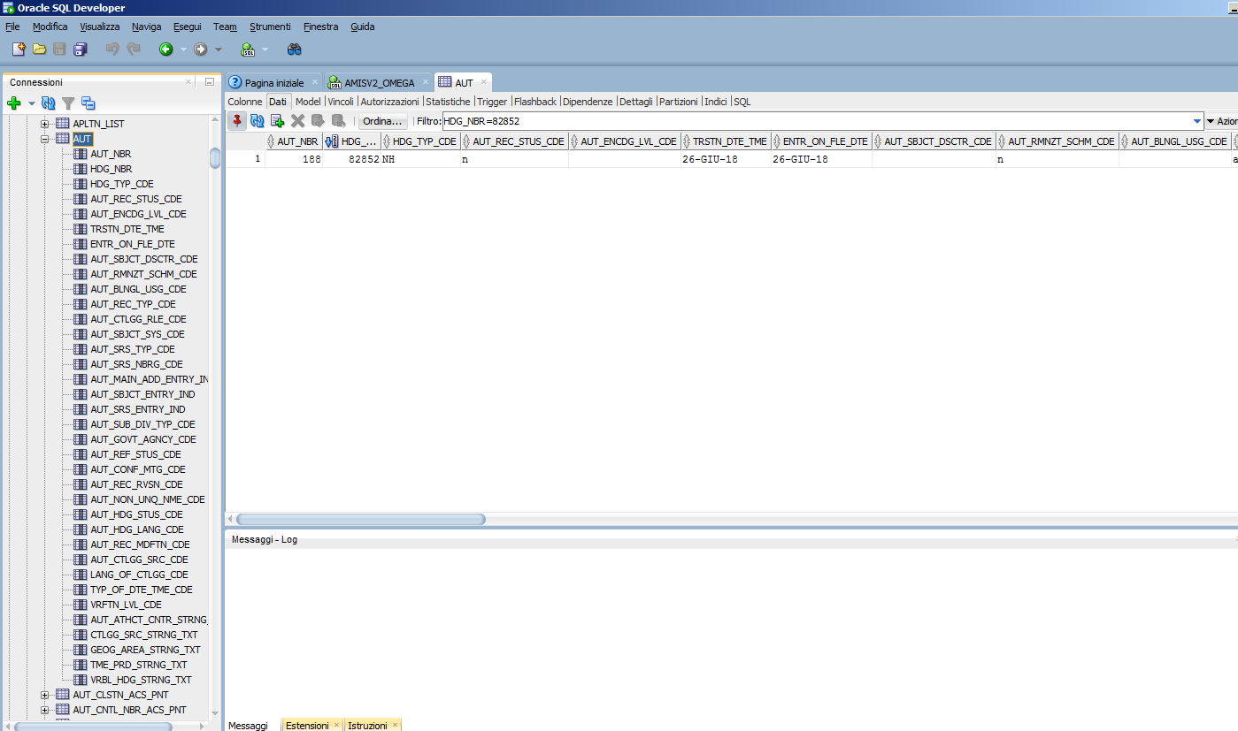

AUT (column)
AUT_NBR |  | Identification number assigned to the authority record that contains the heading name
HDG_NBR | 82852 | Identification number assigned to the heading name, that you’ll find in NME_HDE table
HDG_TYP_CDE | NH | Code to indicate that the heading number is referring to the Name heading (if is SH it will refer to Subject heading, if is TH to the title heading)
AUT_REC_STUS_CDE | n | Leader value (000/05)
AUT_ENCDG_LVL_CDE | n | Leader value (000/17)
TRSTN_DTE_TME | 26-GIU-18 | 005
ENTR_ON_FLE_DTE | 26-GIU-18 | 008/00-05
AUT_SBJCT_DSCTR_CDE |  | 008/06
AUT_RMNZT_SCHM_CDE | e | 008/07
AUT_BLNGL_USG_CDE | e | 008/08
AUT_REC_TYP_CDE | a | 008/09
AUT_CTLGG_RLE_CDE | n | 008/10
AUT_SBJCT_SYS_CDE | n | 008/11
AUT_SRS_TYP_CDE | n | 008/12
AUT_SRS_NBRG_CDE | n | 008/13
AUT_MAIN_ADD_ENTRY_IND | | | 008/14
AUT_SBJCT_ENTRY_IND | b | 008/15
AUT_SRS_ENTRY_IND | b | 008/16
AUT_SUB_DIV_TYP_CDE | n | 008/17
AUT_GOVT_AGNCY_CDE |  | 008/28
AUT_REF_STUS_CDE | n | 008/29
AUT_CONF_MTG_CDE | 2 | OBSOLETE
AUT_REC_RVSN_CDE | a | 008/31
AUT_NON_UNQ_NME_CDE | n | 008/32
AUT_HDG_STUS_CDE | b | 008/33
AUT_HDG_LANG_CDE | und
AUT_REC_MDFTN_CDE |  | 008/38
AUT_CTLGG_SRC_CDE | c | 008/39
LANG_OF_CTLGG_CDE | ita | 040 $b
TYP_OF_DTE_TME_CDE |  | 045 first indicator
VRFTN_LVL_CDE | 2 | Verification level code of the authority (Saved, Preliminary, Verified…)
AUT_ATHCT_CNTR_STRNG_CDE |  | NOT USED
CTLGG_SRC_STRNG_TXT | PS | 040 $a
GEOG_AREA_STRNG_TXT |  | 043
TME_PRD_STRNG_TXT |  | 045
VRBL_HDG_STRNG_TXT |  | Used to save other textual information

Fig.25.

Now the heading is associated to a bibliographic record:
Fig.26.

and to an authority record:
Fig.27.

- Cross reference
You can create a cross-reference while scanning an index or on authority worksheet. If you create a cross-reference and decide to add an authority for one of the headings, WeCat will display the cross reference in the authority worksheet (as tag 4XX/5XX).

4.1 To add a cross-reference

Scan the name (or title or subject or publisher) index for your term (NA Vargas, Fred + SCAN button).
Fig.28.

Move the cursor to the “Refs” column and click on it.

Fig.29.
If there is a reference the “Cross reference summary” window displays. If the heading has no references, click on “New” button to create one.

Your term displays in the Cross reference “From” box.
Fig.30.
Click the arrow besides “Type” to choose one (such as “seen from”)
Fig.31.

In the “To” box, type the related term (Audoin-Rouzeau, Frédérique, 1957-‏) and press “Browse”
Fig.32.

If the heading is not present in the index, you can create a new one as previously explained (selecting “New heading”, adding all subfields and saving it), otherwise, if it’s present, click on it.
Fig.33.
Fig.34.
Now click on “Save cross reference” and the new reference displays in the summary.
Fig.35.

So, now the heading name “Vargas, Fred” has one cross reference.
Fig.36.

To create an authority record starting from this heading, click on “0” in column “A”. WeCat will automatically supply the authority record with that heading name and with tag 400 to display the “see from” reference
Fig.37.

Fig.38.

To resume:
- You can add a cross reference to an heading starting from an index. In this case, if you then will create an authority record for that heading, the record automatically will supply tag 4XX/5XX to display the reference.
- You can add a cross reference starting from the authority record, adding directly tag 4XX/5XX.
Then, scanning the index for the heading specified in tag 1XX of the authority record (Index of name for example), you will see automatically the cross reference .
Fig.39.

- Name/Title management
To create a N/T heading, scan the NT index to be sure that the heading is not already present:
Fig.40.

Fig.41.
The heading is not present, so we create a new one, selecting “New heading”
Fig.42.

In the window for the creation of NT heading (Fig.42), I will able to search the index of Name to find heading Name “Vargas, Fred” and search the index of Title to find “Debout les morts”.
I’ll begin browsing the name:
Fig.43.

Fig.44.
The heading “Vargas, Fred” is already present, so I click on it

WeCat automatically display the Name in the specific box. I continue scanning the index of Title to find: “Debout les morts”
Fig.45.
It’s not present, so I create a new title heading for “Debout les morts” (selecting “New heading”, adding all subfields and saving it).

I click the title heading
Fig.46.

And now I’m able to save the Name-Title heading
Fig.47.

and add to the related index of NT
Fig.48.

Now scanning name NA Vargas
Fig.49.

or scanning title “Debout les morts”
Fig.50.
I’ll see the column NT valorized with value 1. They are both associated to the Name/Title “Vargas, Fred 1957-. Debout les morts”
Fig.50.

We have in the database a table: NME_TTL_HDG, where to the Name/Title heading “Vargas, Fred 1957-. Debout les morts” was associated a NME_TTL_HDG_NBR (1599) and where are stored the heading number of the name (82838= Vargas, Fred … it comes fron NME_HDG table) and the heading number of the title (160924=Debout les morts … it comes from TTL_HDG table).
Fig.51.

- URI management

In WeCat is possible to associate a URI to an heading (title, name, subject …), starting from the index of the related heading.

For example I scan name “NA Vargas, Fred” and select “0” of the column “URI”:
Fig.52.

Fig.53.
WeCat will open the URI management window, displaying the URI associated to the heding, if they are present (in this case no one)

I select “New” button
Fig.54.

and the arrow after “Choose source” to select the source desired to retrieve the related URI
Fig.55.

Fig.56.
Fig.57.

I select the desired URI and SAVE
Fig.58.
This is the VIAF URI associated to heading name “Vargas, Fred”

So, going back on the index of Name for “Vargas, Fred”, I’ll have the following:
Fig.59.

- A N/T associated
- A URI associated
- A Cross reference associated
- An authority record associated

